As you may recall, Proverbs ends with a 22-verse acrostic describing the characteristics of the ideal woman. Of course, many places in scripture depict God’s church as an ideal woman, the affianced bride of Christ. Previous verses have emphasized her surpassing faithfulness and determination to do “good and not evil” for her husband “all the days of her life.” Adding to these characteristics, verses 13 and 14 describe her search for fine fibers and excellent food. The fibers—wool and linen—she uses to produce good clothing and other soft goods for her family’s use. She also produces quality meals, having located the best ingredients at the most economical price, even though they may be purchased “from afar.” She organizes the day’s work “while it is yet night.” Thus her household is orderly, everyone is provided with proper meals, and her servants are given plenty of notice so that they may properly execute their daily tasks. She also deploys her resources with care. Money earned is used to make wise purchases of land, and the land is improved by clearing it and planting it with vines. So her original profit is wisely put to work so that she can earn still more profit. This wealth does not come from another’s loss, but from her own effort and careful management. She is determined to provide the best for her family through her own hard work. What a practical and efficient model for God’s church!

**Proverbs 31:13-16**

**She seeketh wool, and flax, and worketh willingly with her hands.**

**She is like the merchants' ships; she bringeth her food from afar.**

**She riseth also while it is yet night, and giveth meat to her household, and a portion to her maidens.**

**She considereth a field, and buyeth it: with the fruit of her hands she planteth a vineyard.**

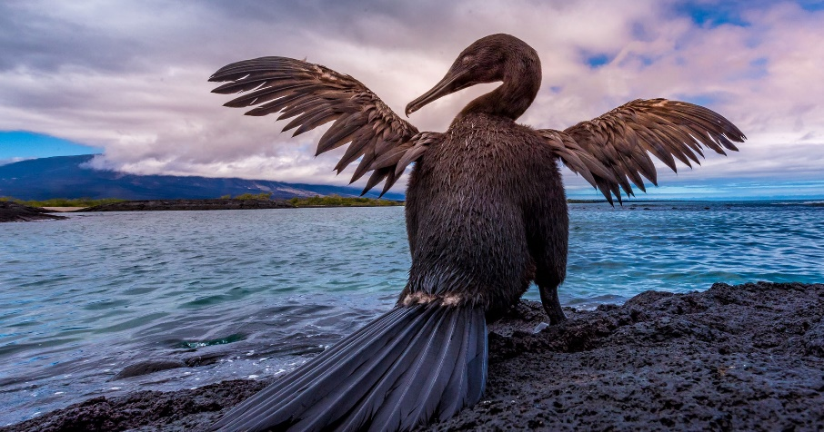**Flightless Cormorants**

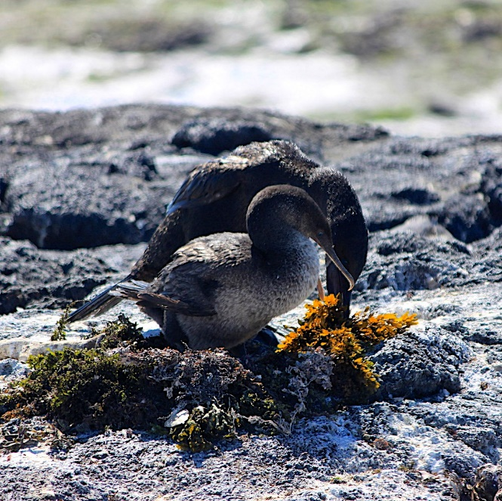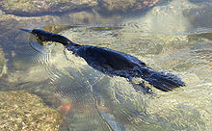Flightless cormorants are native to the Galapagos Islands, and as the name suggests, they cannot fly. They grow to almost 40 inches in length, and weigh between 5½ and 11 pounds. Their wings are about one third the size that they would need to be to carry the bird through the air. Flightless cormorants have webbed feet and sturdy legs, which propel them through the water as they hunt fish and other small marine creatures. They forage underwater, but no more than 650 feet from the shore. Flightless cormorants, like other cormorants, do not have waterproof feathers. Instead, they spend time after each dive drying in the sunlight. Their flight and contour feathers are much like those of other cormorants, but their body feathers are much thicker, softer, denser, and more hair-like. They produce very little oil from their preen gland, so their feathers are not even water-resistant. Instead, it is the air trapped in the dense plumage that prevents them from becoming waterlogged. They’re quite graceful in the water, which is where courtship begins. The male and female swim around each other with necks bent. Then the pair moves onto shore, where they will build their nest. The female seems to control the actual construction of the nest, while the male brings building material. The nest is composed mostly of seaweed, each fragment of which is located by the male and then “gifted” to the female. She chooses which pieces to use, and determines where they should be placed. Both color and texture are considered before a particular section of seaweed is placed within the nest. The females are extremely choosy with regard to both materials and design, because the nest must be as perfect as possible for the chicks to come. Her dedication to producing the absolute best home for her family is much like the dedication of the ideal woman in Proverbs. She spares no effort! As God’s church, we can do no less in our own efforts for Him.

Amazon Prime

Natural World: Animal House

Season 1

Episode 1

Start: 20:37 (31:54 from End)

End: 22:44 (29:47 from End)