These verses continue the acrostic found in the last chapter of Proverbs which describes the ideal woman. In previous verses we’ve seen her described as entirely faithful, trustworthy, and dedicated to providing the best for her family. We have also noted that the ideal woman is used in many parts of scripture to depict God’s church. These verses continue to expand this picture. The ideal woman is shown as physically strong and active. Girding her loins refers to tying up her robes in preparation for active physical exertion. She is not just an overseer or manager! She is herself involved in the physical labor. Verse 18 tells us that she is also on top of the mental work of running such an active household. Her efforts and resources are spent wisely. She investigates every aspect of the work under her management to be certain that it is successful and profitable. Her merchandise—both purchased and produced—is good! And her home is productive and well organized, as signified by the lit “candle.” In an agrarian society, animals must be cared for at first light, and so preparations for breakfast must begin well before that. With men out late working and some staying in the fields all night to protect the herds in darkness, it only made sense to have the lamp burning all night. So in a well-ordered home the light was extinguished only in times of calamity. All moments of the day are filled with productive activity! The ideal woman spins thread herself so that it may be woven into cloth to produce all the soft goods necessary to such a household—clothing, bedding, rugs, curtains, hangings, tents, and more. She is strong, hardworking, productive, and wise. This is an image to which we as a church may aspire. Were we as industrious as the woman depicted here, then our work would be done very soon!

**Proverbs 31:17-19**

**She girdeth her loins with strength, and strengtheneth her arms.**

**She perceiveth that her merchandise is good: her candle goeth not out by night.**

**She layeth her hands to the spindle, and her hands hold the distaff.**

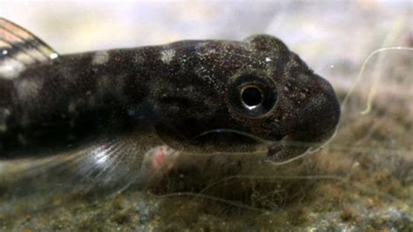**The Nopili Rock Climbing Goby**

These remarkable gobies live in Hawaii, and they begin life as tiny saltwater juveniles in the ocean reefs surrounding the islands. But when they get to be about an inch long, they undergo a startling transformation. Their skull structure changes and their mouths move from the front of the head down underneath their bodies. As juveniles, these gobies are omnivorous, but they become vegetarians (obligate algal grazers) when they go through this change. In addition to using their new mouth parts to eat differently, they also use the new position of their mouth as a sucker to do something quite astounding. They climb waterfalls. Big ones. These little fish—only about an inch long—can climb up waterfalls that are 330 feet tall. The path to the top can be quite tricky, because they can’t resist the pressure of the water in the deepest parts, but they do need a thin film of water over the rock in order to be able to cling to it. Finding the correct path to the top is quite a job. Fortunately, they’re quite clever. There’s been some experimentation, and it looks like they can learn directional cues, including local landmarks and chemical signals, in less than 10 minutes. They may actually “scent” the paths of gobies who have made the journey previously. It’s an extremely difficult journey, and it takes a goby that is strong, persistent, and clever to make it to the top. Not every goby that undertakes the trip is successful. But those that do manage the feat reach fast-moving streams where algae grows plentifully on the rocks and predators are left far behind. Their sucker-mouth is useful to help them hold their place in the flow, and they can eat at the same time. Here the rock-climbing gobies reach maturity, growing up to about 7 inches long, and find mates. When their eggs hatch, the young are swept quickly downriver to the sea, to grow until they attempt the trip themselves. These are some strong and persistent fish! They need wisdom too, if their journey is to be successful. The ideal woman has similar qualities! Strength, industriousness, and wisdom are her hallmarks. They’re fine qualities to which anyone might aspire! And they’re wonderful qualities for anyone who is a member of God’s remnant church!

Amazon Prime

Life

Season 1

Episode 4: “Fish”

Start: 24:35 (23:33 from End)

End: 28:27 (19:41 from End)