As you probably recall, the book of Proverbs concludes with this acrostic describing the qualities of the ideal woman. In many places in scripture, God’s church is represented as just such a woman. This poem has already described her as faithful, hardworking, productive, and dedicated to providing the best for her family, as well as being both strong and wise. Some of these qualities are touched on again in this section, but the emphasis is different. These verses depict the ideal woman’s influence on those around her. She is merciful to the poor and makes some provisions for the needy. The model of skillful efficiency, such a woman certainly can have little tolerance for sloth. But she is pictured as being generous with those who are less able or skilled. No doubt some of her own prosperity is due to her consideration for those in need and the consequent blessing and approval of God. Her generosity does not hinder the prosperity of her own household. Instead her family and servants are provided with fine, warm clothing in scarlet, while her own clothes are of fine pure white linen and royal purple. Her household is a model of prosperity in red. This is a fitting symbol of the character of the people in God’s church—covering our own defects with the blood of the Lamb. Her husband is “known in the gates,” which was a desirable honor of the time. The good reputation of such a wife, and the wealth which she helped to create, would elevate the husband’s reputation also. This is godly influence at its finest! The church is meant to have a powerful reputation, bringing honor to those who participate with “her” and displaying God’s blessings to all.

**Proverbs 31:20-23**

**She stretcheth out her hand to the poor; yea, she reacheth forth her hands to the needy.**

**She is not afraid of the snow for her household: for all her household are clothed with scarlet.**

**She maketh herself coverings of tapestry; her clothing is silk and purple.**

**Her husband is known in the gates, when he sitteth among the elders of the land.**

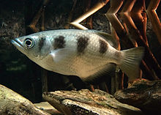**Archerfish**

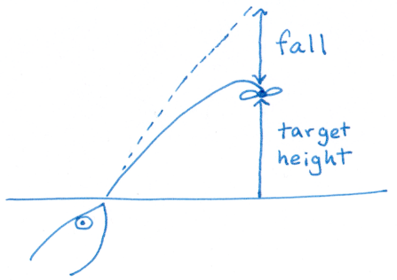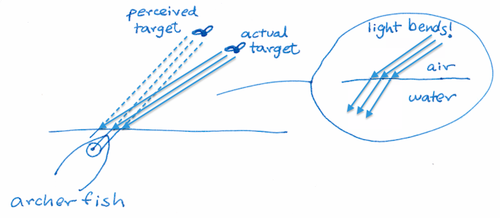Archerfish are completely remarkable fish that live in Asia—from India, Bangladesh and Sri Lanka, throughout Southeast Asia, to Northern Australia and Melanesia. There are ten species of archerfish, mostly living in fresh water rivers, streams, and pools, although there are some that will tolerate brackish water habitats such as estuaries and mangroves. They don’t look terribly remarkable, being smallish (5-7 inches) striped fish with jutting lower jaws. But they are remarkable all the same! Archerfish capture prey—mostly small insects—in an astonishing fashion. They shoot a stream of water from their mouths, firing at insects on nearby plants with enough force to knock them into the water. They can hit insects up to 10 feet above the surface of the water. And they are incredibly accurate! An adult archerfish almost always hits the target on their first shot. This is even more remarkable than it might seem, since water refracts light. The insect is not where the fish perceives it to be, because light bends when it hits the water. Also, they can’t shoot water in a truly straight line. Gravity has an effect on the stream of water, giving it a parabolic curve which the fish must accommodate. Fortunately, God has made the archerfish remarkable in another way. They are one of the few species of fish which have demonstrated “social learning.” Young archerfish aren’t very good shots. It takes many, many attempts to learn to compensate for light refraction and the effects of gravity. But young fish can shortcut the process by studying an adult’s technique. We’re not sure how, but they seem to calculate the angles and make adjustments to imitate their mentor. Adults don’t have to put up with this. Being larger, they can drive the young fish off or even follow them around stealing their prey. But many adults seem willing to put up with a student or two. It seems they wish to have a positive influence on the “needy” juveniles, helping the next generations to succeed just as they have. Their community succeeds and grows because these adults use the influence that they have for the benefit of all. The church has a similar goal!

Amazon Prime

Life Story

Season 1

Episode 4: “Power”

Start: 28:21 (21:52 from End)

End: 31:31 (18:42 from End)