Context is critical in Bible study, and these verses are no exception! It’s important to remember that the verses immediately preceding these gave stern warnings against self-indulgence. They form part of the guidance given by King Lemuel’s mother, including a particular warning against princes indulging in strong drink. Alcohol was one of the few medications available at the time. It was to be used when needed and not used recreationally. In other words, we are to use strong medicine when medically appropriate—as a mercy for those suffering severe illness. This requirement for merciful behavior continues in verses 8 and 9, which urge Lemuel to stand up and plead the cause of any who cannot speak for themselves. These ideas naturally apply not just to kings but to community leaders of all kinds. All of the advice for communities and leaders in Proverbs is very consistent! We are directed to care for one another, be merciful to each other, and to preference the needs of others above our own wants. This is the very opposite of self-indulgence, which was warned against in the previous verses. As Christians we have an obligation not just to be gentle with others but to actually sacrifice our own needs for theirs! Jesus modeled this behavior for us in His own human existence, and the Holy Spirit helps us to model it in our own.

**Proverbs 31:6-9**

**Give strong drink unto him that is ready to perish, and wine unto those that be of heavy hearts.**

**Let him drink, and forget his poverty, and remember his misery no more.**

**Open thy mouth for the dumb in the cause of all such as are appointed to destruction.**

**Open thy mouth, judge righteously, and plead the cause of the poor and needy.**

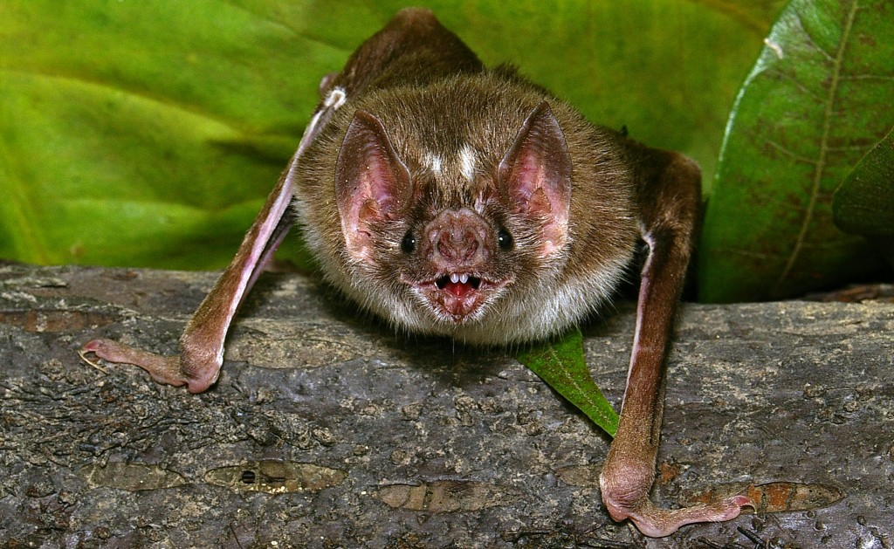**Vampire Bats**

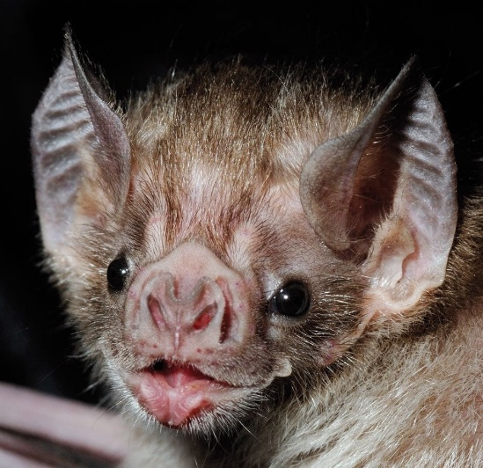The common vampire bat (Desmodus rotundus) is a small, leaf-nosed bat native to Latin America. It is one of only three existing species of vampire bat, the other two being the hairy-legged and the white-winged vampire bats. As you would probably guess, vampire bats eat blood, mainly feeding on the blood of livestock. Unlike other bats, vampire bats can maneuver efficiently on the ground. They have a unique, bounding gait in which the forelimbs are used instead of the hindlimbs to propel the animal forward. So they are able to creep up on sleeping animals from the ground, usually approaching the rump, flank, or neck of its prey while they are sleeping. Heat sensors in the bat’s nose help it to detect blood vessels near the surface of the skin. It then uses its razor-sharp teeth to slice the skin, lapping up blood with its long tongue. Disturbing though they are, vampire bats are very small, only about three and a half inches long and two ounces in weight. Every night they must travel between 3 and 5 miles from their roosts to hunt. The gruesome diet of the vampire bat involves a number of difficulties. Blood has quite a bit of iron and protein in it, both of which are potentially problematic in sufficient quantities, but it contains almost no fat. So vampire bats have difficulty getting enough energy. They must consume at least half their own body weight in blood each night or they will quickly become weak and die. But bats don’t hunt successfully every night. To compensate for this, vampire bats have a startling behavior: they share. Bats who have successfully fed that night regurgitate blood for those bats who have not. It seems an act of mercy. Considering a vampire bat’s own desperate need for energy, this is an extremely surprising strategy! But the whole colony benefits from this cooperative attitude. Mercy and community cooperation have made vampire bats quite successful survivors. It seems that Proverbs suggests the same for us!

Amazon Prime

Natural Curiosities

Season 2

Episode 5: “Bad Reputations”

Start: 12:42 (9:14 from End)

End: 19:49 (2:07 from End)