**The Polar Bear**

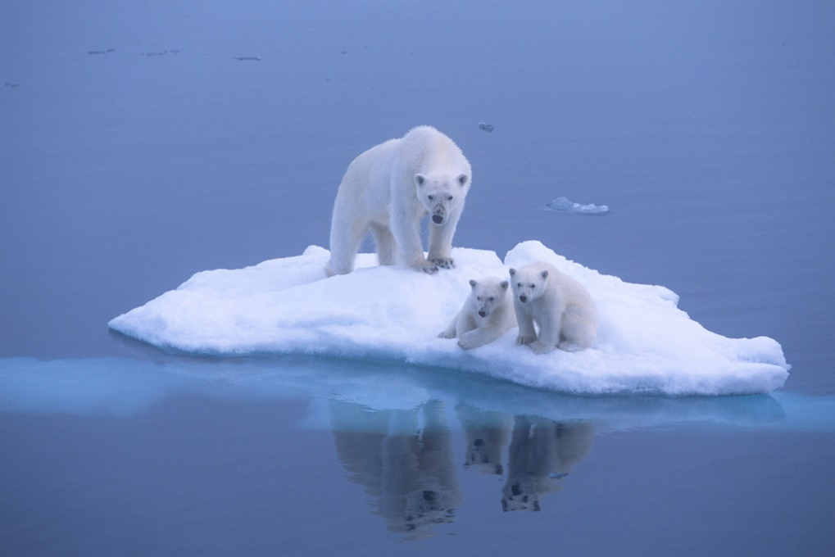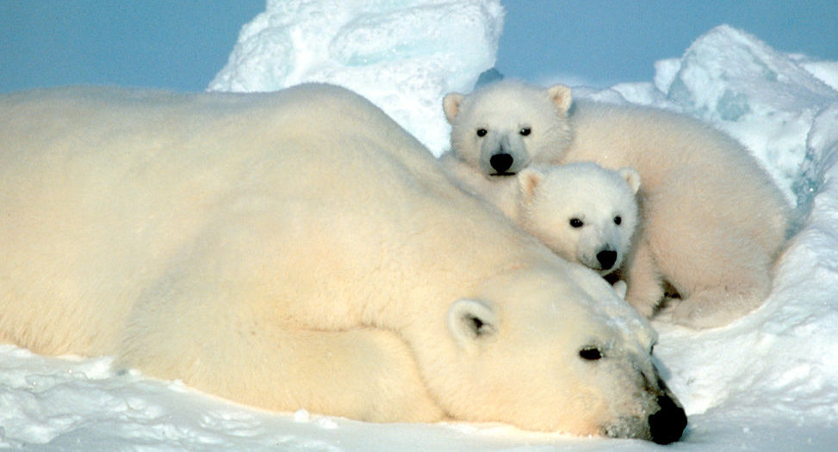We’ve all seen the photos of polar bears floating on an isolated chunk of ice, staring out at the unforgiving sea. There is much concern about the future of the polar bear, given global warming, shrinking sea ice, and diminished polar bear populations. In truth, there is just a lot we don’t know about global warming, whether or not the sea ice is actually shrinking, and how bear populations are changing. The trouble is that polar bears have such a vast range, including much temporary, shifting sea ice, that tracking them is expensive and very difficult. Current data states that of the 19 established subpopulations, 3 are stable, 1 is increasing, and 8 are decreasing. There isn’t enough data on the other 7 to suggest what’s happening. The trouble is that this data is misleading. It treats these populations as separate, when DNA tests and GPS tracking say that there is considerable interaction between them. So no one really knows how polar bear populations are shifting. Native peoples—those that actually live in the desolate arctic regions inhabited by polar bears—say that populations are on the rise. It is interesting to note that these are the people responsible for issuing (perfectly legal) polar-bear hunting permits, so perhaps they have a good grasp on population levels.

Polar bears seem to need a lot of really good luck to survive. They have to find their way across hundreds of miles of ever-changing terrain, all of which could turn into open water at nearly any moment. Fortunately, God looks after all of His creations. Polar bears really need God to direct their paths! He also gave them some astonishing abilities. Polar bears are incredibly curious and intelligent. They can actually swim for hundreds of miles in the sea. If necessary, polar bears can become omnivorous or go without eating for months at time.

Polar bears have survived this long, no doubt due to God’s grace. If we trust in the Lord with all our hearts, and lean not unto our own understanding, in all our ways acknowledging Him, then He shall direct our paths. We don’t need to be anxious about any of those things which threaten us. If He protects the polar bears in their paths across the sea ice, then we can be sure that He will direct ours as well.

**Proverbs 3:1-10**

**My son, forget not my law; but let thine heart keep my commandments:**

**For length of days, and long life, and peace, shall they add to thee.**

**Let not mercy and truth forsake thee: bind them about thy neck; write them upon the table of thine heart:**

**So shalt thou find favour and good understanding in the sight of God and man.**

**Trust in the Lord with all thine heart; and lean not unto thine own understanding.**

**In all thy ways acknowledge him, and he shall direct thy paths.**

**Be not wise in thine own eyes: fear the Lord, and depart from evil.**

**It shall be health to thy navel, and marrow to thy bones.**

**Honour the Lord with thy substance, and with the firstfruits of all thine increase:**

**So shall thy barns be filled with plenty, and thy presses shall burst out with new wine.**