**Proverbs 3:27-35**

**Withhold not good from them to whom it is due, when it is in the power of thine hand to do it.**

**Say not unto thy neighbour, Go, and come again, and to morrow I will give; when thou hast it by thee.**

**Devise not evil against thy neighbour, seeing he dwelleth securely by thee.**

**Strive not with a man without cause, if he have done thee no harm.**

**Envy thou not the oppressor, and choose none of his ways.**

**For the froward is abomination to the LORD: but his secret is with the righteous.**

**The curse of the LORD is in the house of the wicked: but he blesseth the habitation of the just.**

**Surely he scorneth the scorners: but he giveth grace unto the lowly.**

**The wise shall inherit glory: but shame shall be the promotion of fools.**

Last week we spoke about the astonishing interconnectedness of the natural world. We saw some dolphins, and a determined tusked fish, who were placed in the precise environment necessary to their success. If you remember, we thought about the ways in which God has placed various creatures in the coral reef so that everything works together to provide precisely what is necessary for their lives. We had this verse in particular:

**“The Lord by wisdom hath founded the earth; by understanding hath he established the heavens. By his knowledge the depths are broken up, and the clouds drop down the dew.” –Proverbs 3:19-20**

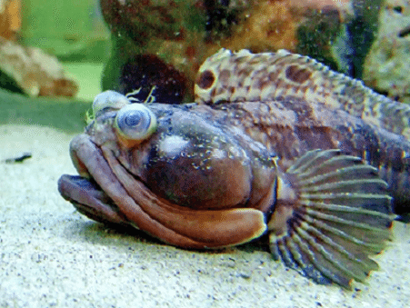This week’s verses in Proverbs invite us to consider the implications of these thoughts as regards our neighbors. Like the dolphins and the tusked fish, God has placed us in the precisely correct environment, so that we have everything we need to develop into the people that He expects us to be. With this thought in mind, consider a strange denizen of the coral reef known as the Sarcastic Fringehead.

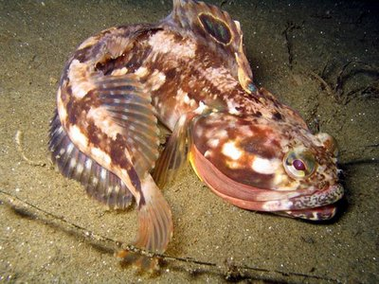

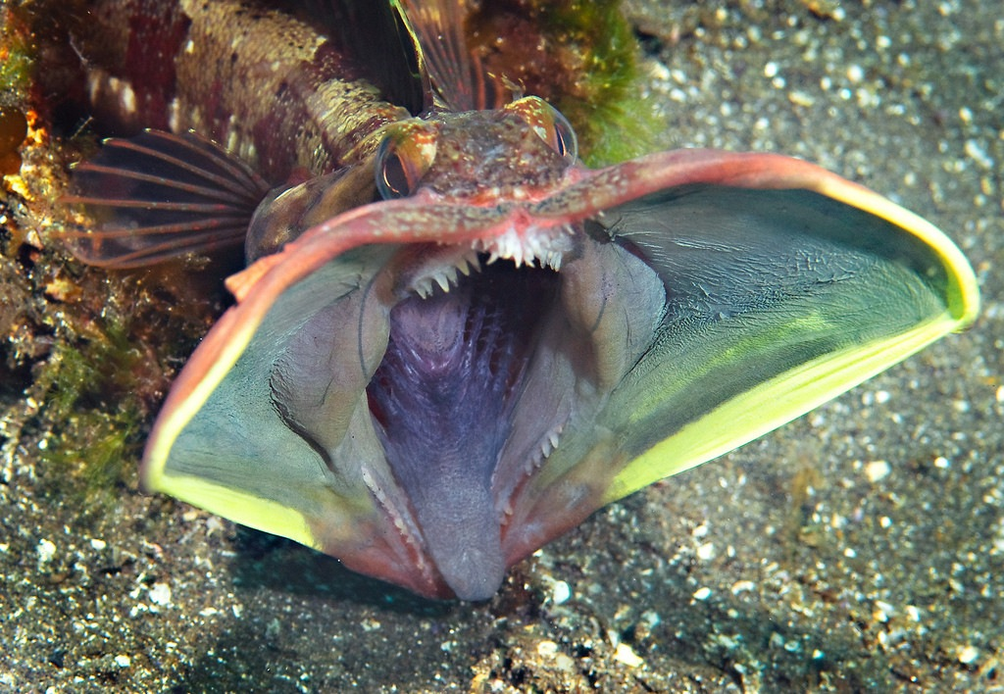This small but aggressive fish doesn’t care for neighbors. The sarcastic fringehead will challenge any creature that it perceives as invading its territory. And it has an astonishing way of showing its disapproval. It can extend its jaws to an incredible range, presenting this terrifying, all but alien picture to any invader:

**Yikes!** Fortunately this display is generally harmless, but the fringehead will harass any intruders until they leave its territory.

As these verses in Proverbs suggest, we want to avoid treating our neighbors this way. Having (hopefully) much more advanced reasoning skills than the sarcastic fringehead, we can appreciate that God has placed us in the environment that is best suited to guide us toward the character that He intends for us to develop. This is something to keep in mind if you happen to have a sarcastic fringehead for a neighbor!