**Proverbs 4:1-13**

**Hear, ye children, the instruction of a father, and attend to know understanding.**

**For I give you good doctrine, forsake ye not my law.**

**For I was my father's son, tender and only beloved in the sight of my mother.**

**He taught me also, and said unto me, Let thine heart retain my words: keep my commandments, and live.**

**Get wisdom, get understanding: forget it not; neither decline from the words of my mouth.**

**Forsake her not, and she shall preserve thee: love her, and she shall keep thee.**

**Wisdom is the principal thing; therefore get wisdom: and with all thy getting get understanding.**

**Exalt her, and she shall promote thee: she shall bring thee to honour, when thou dost embrace her.**

**She shall give to thine head an ornament of grace: a crown of glory shall she deliver to thee.**

**Hear, O my son, and receive my sayings; and the years of thy life shall be many.**

**I have taught thee in the way of wisdom; I have led thee in right paths.**

**When thou goest, thy steps shall not be straitened; and when thou runnest, thou shalt not stumble.**

**Take fast hold of instruction; let her not go: keep her; for she is thy life.**

God has not asked us to “get wisdom” by ourselves! He has given us parents, families, and church families who help us gain wisdom as we grow in Him. And we’re not the only ones! God has provided lots of creatures with a family to help them get wisdom. Let’s talk about one small animal that has a very big family—the Meerkat.

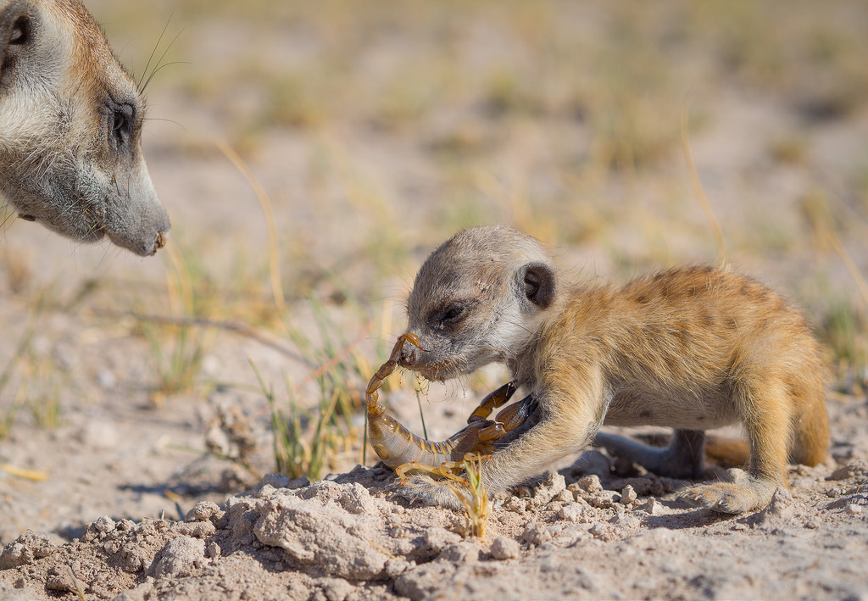Meerkat families are very large, and are organized under a “queen,” that is, a mature female. She is almost always the only one to have babies, and her entire family helps with the raising of them.

In particular, the mature members of the family teach the young ones how to find food. This help is really a necessary thing when your food is inclined to bite back! Baby meerkats need to learn how to disable scorpion stings, and how to face down the snakes who live in their territory. Fortunately, God has provided them with families to teach them, just as He has for us.