

**Proverbs 4:14-27**

**Enter not into the path of the wicked, and go not in the way of evil men.**

**Avoid it, pass not by it, turn from it, and pass away.**

**For they sleep not, except they have done mischief; and their sleep is taken away, unless they cause some to fall.**

**For they eat the bread of wickedness, and drink the wine of violence.**

**But the path of the just is as the shining light, that shineth more and more unto the perfect day.**

**The way of the wicked is as darkness: they know not at what they stumble.**

**My son, attend to my words; incline thine ear unto my sayings.**

**Let them not depart from thine eyes; keep them in the midst of thine heart.**

**For they are life unto those that find them, and health to all their flesh.**

**Keep thy heart with all diligence; for out of it are the issues of life.**

**Put away from thee a froward mouth, and perverse lips put far from thee.**

**Let thine eyes look right on, and let thine eyelids look straight before thee.**

**Ponder the path of thy feet, and let all thy ways be established.**

**Turn not to the right hand nor to the left: remove thy foot from evil.**

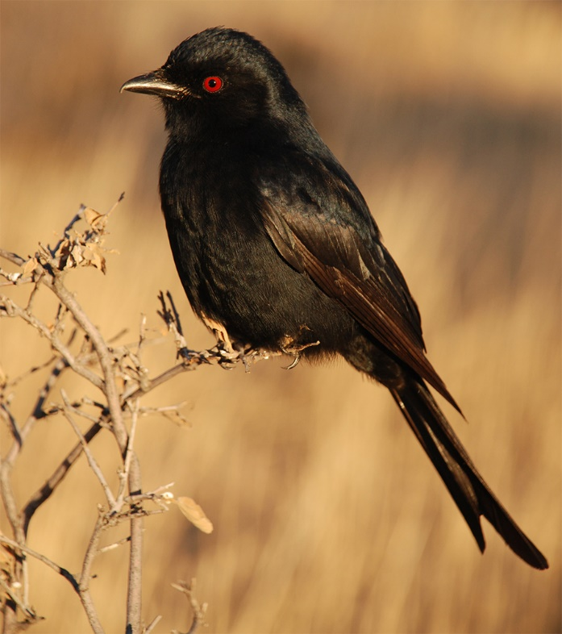Of course we know that unlike people, animals seldom hurt others out of sheer wickedness. But there are some that definitely and deliberately mislead others for their own benefit.

The drongo, a South African bird, provides a good example. This little creature has set up a protection racket. He acts as a sentry for his neighbors, calling out a warning whenever a predator approaches. The other creaturs heed his warning, and scramble to escape the threat. It all seems very public minded. But this isn’t a community service, and it isn’t free.

Every once in a while, when a particularly nice morsel pops up, the drongo sounds the alert and his neighbors flee for shelter. But it’s a trick. There is no predator. Instead, the drongo clears the field so that he can swoop down and eas whatever food his neighbors have located. You just can’t trust some birds!

Of course, the drong is providing a valuable (though somewhat disingenuous) service to his neighbors, although they might not always appreciate it. People can be quite a lot worse, as these verses suggest. Fortunately, unlike these savanna animals, we have Biblical guidance to help us decide who we should –and shouldn’t—trust.

**The Farmer and the Viper**

One winter a Farmer found a Viper frozen and numb with cold, and out of pity picked it up and placed it in his coat. The Viper was no sooner revived by the warmth than it turned upon its benefactor and inflicted a fatal bite upon him; and as the poor man lay dying, he cried, "I have only got what I deserved, for taking compassion on so villainous a creature."

The idea framed in these verses is also represented in one of Aesop’s fables, “The Farmer and the Viper.” It’s a warning. Some people are just, well, poisonous. And there is one way to deal with them and their machination. As these verses say, “Avoid it, pass not by it, turn from it, and pass away.” --Proverbs 4:15