

**Proverbs 5:1-23**

**My son, attend unto my wisdom, and bow thine ear to my understanding: That thou mayest regard discretion, and that thy lips may keep knowledge. For the lips of a strange woman drop as an honeycomb, and her mouth is smoother than oil: But her end is bitter as wormwood, sharp as a twoedged sword. Her feet go down to death; her steps take hold on hell.**

**Lest thou shouldest ponder the path of life, her ways are moveable, that thou canst not know them. Hear me now therefore, O ye children, and depart not from the words of my mouth. Remove thy way far from her, and come not nigh the door of her house: Lest thou give thine honour unto others, and thy years unto the cruel: Lest strangers be filled with thy wealth; and thy labours be in the house of a stranger;**

**And thou mourn at the last, when thy flesh and thy body are consumed, And say, How have I hated instruction, and my heart despised reproof; And have not obeyed the voice of my teachers, nor inclined mine ear to them that instructed me! I was almost in all evil in the midst of the congregation and assembly.**

**Drink waters out of thine own cistern, and running waters out of thine own well. Let thy fountains be dispersed abroad, and rivers of waters in the streets. Let them be only thine own, and not strangers' with thee. Let thy fountain be blessed: and rejoice with the wife of thy youth. Let her be as the loving hind and pleasant roe; let her breasts satisfy thee at all times; and be thou ravished always with her love.**

**And why wilt thou, my son, be ravished with a strange woman, and embrace the bosom of a stranger? For the ways of man are before the eyes of the LORD, and he pondereth all his goings. His own iniquities shall take the wicked himself, and he shall be holden with the cords of his sins. He shall die without instruction; and in the greatness of his folly he shall go astray.**

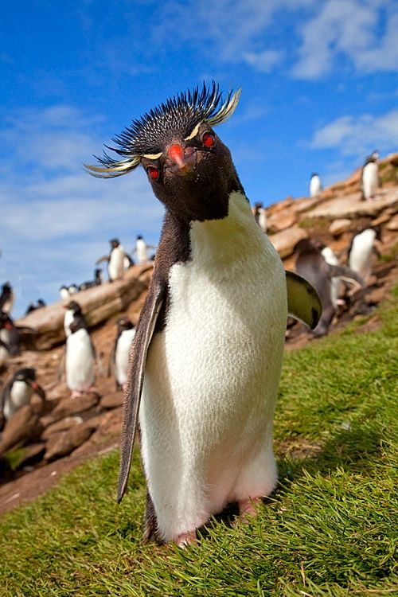**The Rockhopper Penguin**

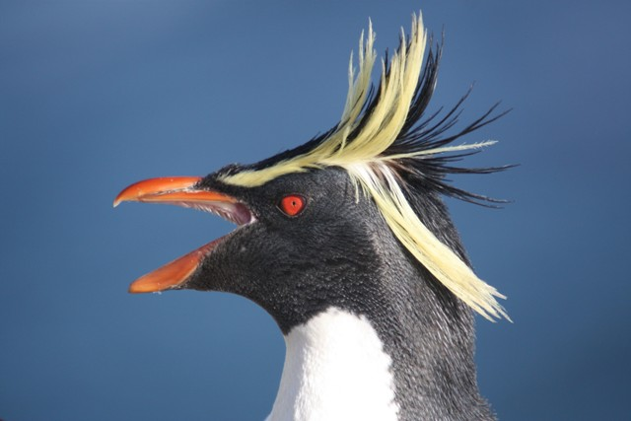**The Rockhopper penguin is a clever and very social bird. Like most penguins, they live in the ocean, where they feed on krill and small crustaceans. When the time comes for breeding, however, they head for rocky shorelines and cool, temperate climates like those to be found in the Falkland Islands, Argentina, Chile, and several different island chains in the Indian Ocean. The fact that concerns us most for today is that Rockhopper penguins mate for life.**

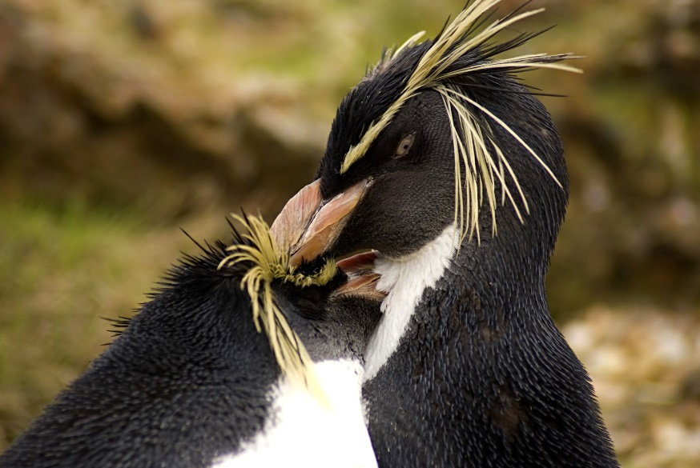**God has pointed out in many places in His Word that we, also, are meant to be mated for life. These verses in Proverbs allude to some of the disasters that can result from disregarding this policy.**

**For penguins or people, straying from our intended mates creates grief, chaos, and occasionally, slap fights. God’s plan for a happy life definitely includes instructions for avoiding this kind of grief.**