**Proverbs 8:1-11**

**Doth not wisdom cry? and understanding put forth her voice?**

**She standeth in the top of high places, by the way in the places of the paths.**

**She crieth at the gates, at the entry of the city, at the coming in at the doors.**

**Unto you, O men, I call; and my voice is to the sons of man.**

**O ye simple, understand wisdom: and, ye fools, be ye of an understanding heart.**

**Hear; for I will speak of excellent things; and the opening of my lips shall be right things.**

**For my mouth shall speak truth; and wickedness is an abomination to my lips.**

**All the words of my mouth are in righteousness; there is nothing froward or perverse in them.**

**They are all plain to him that understandeth, and right to them that find knowledge.**

**Receive my instruction, and not silver; and knowledge rather than choice gold.**

**For wisdom is better than rubies; and all the things that may be desired are not to be compared to it.**

God has gifted us with the ability to understand many things, but it is all too easy for us to confuse wisdom and knowledge. This chapter reminds us that as Christians we are to seek wisdom—not just knowledge or understanding—and that wisdom comes from God. But He does not hide it from us, indeed, it “crieth from the gates,” and “from the top of high places.” But somehow it can still be hard to find.

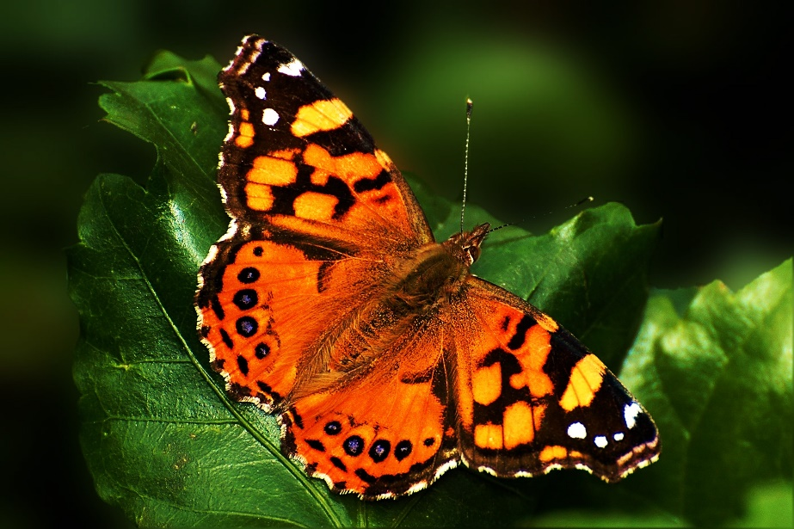**The Painted Lady Butterfly**

These butterflies are the most widely distributed in the world. They can be found on every continent except Australia and Antarctica. These medium-sized butterflies can cover a lot of ground, up to 100 miles per day during their migration. A painted lady is capable of reaching a speed of nearly 30 miles per hour. When migrating, they can fly at such high altitudes that they are not visible to observers on the ground. They simply appear in new areas without warning.

Like other butterflies, painted ladies begin their life as a caterpillar, changing into their adult form within a chrysalis. Of course, this is now well-known to science, but it was not always that way. In this short video, we see David Attenborough, a highly respected naturalist, attempting to excuse this ignorance in these words:

**“At the time, many still believed that caterpillars and butterflies were completely different creatures, created by the hand of God.”**

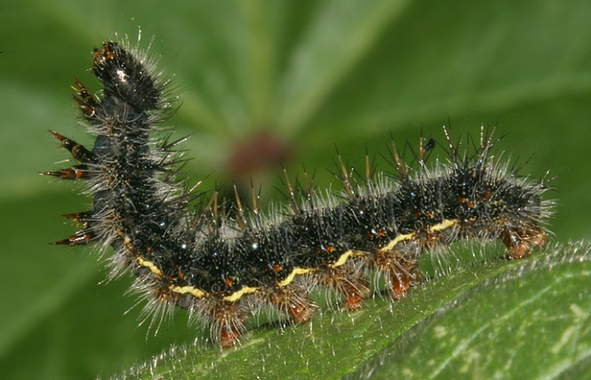Today even small children are aware of the connection between caterpillars and butterflies, of course. But you have to question whether this is an increase in wisdom or merely in knowledge. Perhaps in the 1800’s, when “many still believed” that such creatures were “created by the hand of God,” there was a greater degree of wisdom than we have today—whether or not they were familiar with the butterfly’s life cycle. Today we have the opportunity to appreciate the butterfly’s miraculous transformation. Observing God’s creation and attempting to understand its complexities is a worthy goal. But true wisdom comes from understanding that, whatever their form, these creatures were indeed created by the hand of God.