These verses list some of the good things that come from having true wisdom—that is, wisdom that comes from God. Prudence, scientific insight, good counsel, strength, good judgement, righteousness, and “substance” or “durable riches” are a few of the benefits of wisdom that are listed here.

**Proverbs 8:12-21**

**I wisdom dwell with prudence, and find out knowledge of witty inventions.**

**The fear of the LORD is to hate evil: pride, and arrogancy, and the evil way, and the froward mouth, do I hate.**

**Counsel is mine, and sound wisdom: I am understanding; I have strength.**

**By me kings reign, and princes decree justice.**

**By me princes rule, and nobles, even all the judges of the earth.**

**I love them that love me; and those that seek me early shall find me.**

**Riches and honour are with me; yea, durable riches and righteousness.**

**My fruit is better than gold, yea, than fine gold; and my revenue than choice silver.**

**I lead in the way of righteousness, in the midst of the paths of judgment:**

**That I may cause those that love me to inherit substance; and I will fill their treasures.**

**This section of Proverbs 8 uses a rhetorical device: personification. Solomon writes as though “Wisdom” were speaking to us directly, as if “Wisdom” were a person who could give direct advice.**

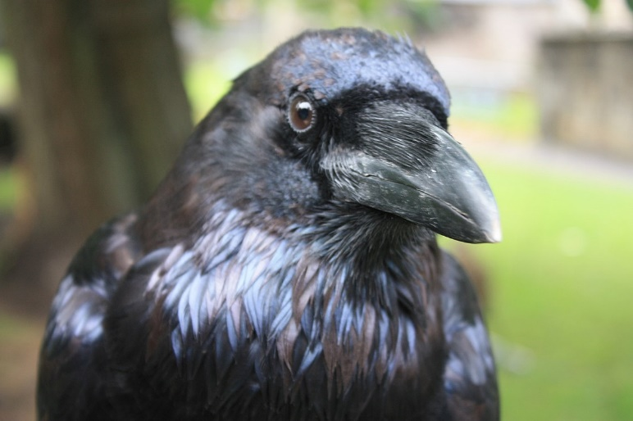**Ravens**

Ravens are large, tough, and clever birds. They can be about 26 inches long, and have a wingspan of more than 4 feet. They are also long-lived birds. We have a record of one captive raven living for 69 years.

Ravens can solve puzzles, anticipate reactions, and create and use tools. They are extremely observant, and have complex social relationships. Ravens are known to collect items of value that they may have a use for later—either as a tools or as goods for barter. This behavior indicates that they are capable of planning for the future at some level. Some scientists have argued that ravens are one of only four known animals (the others being bees, ants, and humans) who have demonstrated the capacity to communicate about objects or events that are distant in space or time from the communication.

Another indicator of intelligence is playfulness. Young ravens have been observed to slide down snowbanks for fun, and engage in games with other species, such as playing tag with wolves, otters and dogs. They are also one of only a few wild animals who make their own toys. They have been observed breaking off twigs to play with socially.

Do these birds display wisdom? It’s hard to say. We know that they do listen to and obey God (1 Kings 17). And they seem to have some of the benefits of wisdom that are listed here. Ravens are prudent, and display a certain scientific insight. They certainly have good judgement, and can even be said to have “substance,” in that they collect and cache food and other items that may be useful to them in the future. Perhaps God gave us the raven as an example, a guide to gaining wisdom of our own.