**Proverbs 8:22-36**

**The LORD possessed me in the beginning of his way, before his works of old.**

**I was set up from everlasting, from the beginning, or ever the earth was.**

**When there were no depths, I was brought forth; when there were no fountains abounding with water.**

**Before the mountains were settled, before the hills was I brought forth:**

**While as yet he had not made the earth, nor the fields, nor the highest part of the dust of the world.**

**When he prepared the heavens, I was there: when he set a compass upon the face of the depth:**

**When he established the clouds above: when he strengthened the fountains of the deep:**

**When he gave to the sea his decree, that the waters should not pass his commandment: when he appointed the foundations of the earth:**

**Then I was by him, as one brought up with him: and I was daily his delight, rejoicing always before him;**

**Rejoicing in the habitable part of his earth; and my delights were with the sons of men.**

**Now therefore hearken unto me, O ye children: for blessed are they that keep my ways**

**Hear instruction, and be wise, and refuse it not.**

**Blessed is the man that heareth me, watching daily at my gates, waiting at the posts of my doors.**

**For whoso findeth me findeth life, and shall obtain favour of the LORD.**

**But he that sinneth against me wrongeth his own soul: all they that hate me love death.**

Recall that “Wisdom” is speaking here in the first person. Is anyone else reminded by this passage of these statements from Job?

“Canst thou draw out leviathan with an hook? or his tongue with a cord which thou lettest down? Canst thou put an hook into his nose? or bore his jaw through with a thorn? Will he make many supplications unto thee? will he speak soft words unto thee?” -Job 41:1-3

“Where wast thou when I laid the foundations of the earth? declare, if thou hast understanding. Who hath laid the measures thereof, if thou knowest? or who hath stretched the line upon it? Whereupon are the foundations thereof fastened? or who laid the corner stone thereof; When the morning stars sang together, and all the sons of God shouted for joy?” -Job 38:4-7

These verses remind us of how much we do not know! Wisdom must come directly from God, and for all of our human scientific accomplishments, there is so much that we just don’t understand.

**[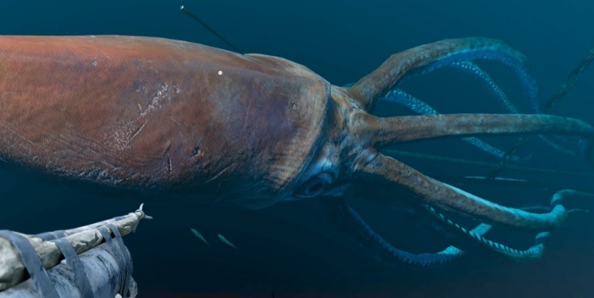](http://www.henspark.com/wp-content/uploads/2010/11/Colossal-Squid.jpg)The Giant Squid**

There is a lot that we don’t know about this denizen of the deep, but we are aware that it can grow to a length of 60 feet and weigh up to a ton. It has huge eyes, with a diameter of 15 inches, and a vast reach of more than 35 feet. It lives in the deep ocean at depths from 700 feet to more than 3000 feet. We’ve found evidence of them, but we have very few images of a live giant squid, and even less understanding of its behavior. Mysterious creatures like this remind us that sometimes we must seek knowledge, as well as wisdom, directly from the Source, because all our amazing low-light cameras, submersibles, and other technology are not sufficient to the task. The complexities of life on this earth are so vast and so subtle that only our Creator understands the intricate ways that they all fit together.