**Proverbs 9:1-9**

**Wisdom hath builded her house, she hath hewn out her seven pillars:**

**She hath killed her beasts; she hath mingled her wine; she hath also furnished her table.**

**She hath sent forth her maidens: she crieth upon the highest places of the city,**

**Whoso is simple, let him turn in hither: as for him that wanteth understanding, she saith to him,**

**Come, eat of my bread, and drink of the wine which I have mingled.**

**Forsake the foolish, and live; and go in the way of understanding.**

**He that reproveth a scorner getteth to himself shame: and he that rebuketh a wicked man getteth himself a blot.**

**Reprove not a scorner, lest he hate thee: rebuke a wise man, and he will love thee.**

**Give instruction to a wise man, and he will be yet wiser: teach a just man, and he will increase in learning.**

We see again that “Wisdom” is personified as a woman. Here she builds a figurative house, a place at which people may call in order to receive her advice. It is represented as a perfect or complete house with seven pillars. In this passage “Wisdom” prepares a feast, sending out her servants to announce it, so that the people may come in and partake of her knowledge and understanding. Of course, only those who recognize their need of wisdom, the “simple” actually come in to her to receive advice. Those who are falsely confident in their own understanding, the “wicked” and the “scorners,” turn away the generous invitation. Such people cannot appreciate Wisdom or her advice.

**[](http://www.newsbiscuit.com/wp-content/uploads/2011/04/Lovable-chimp.jpg)Chimpanzees**

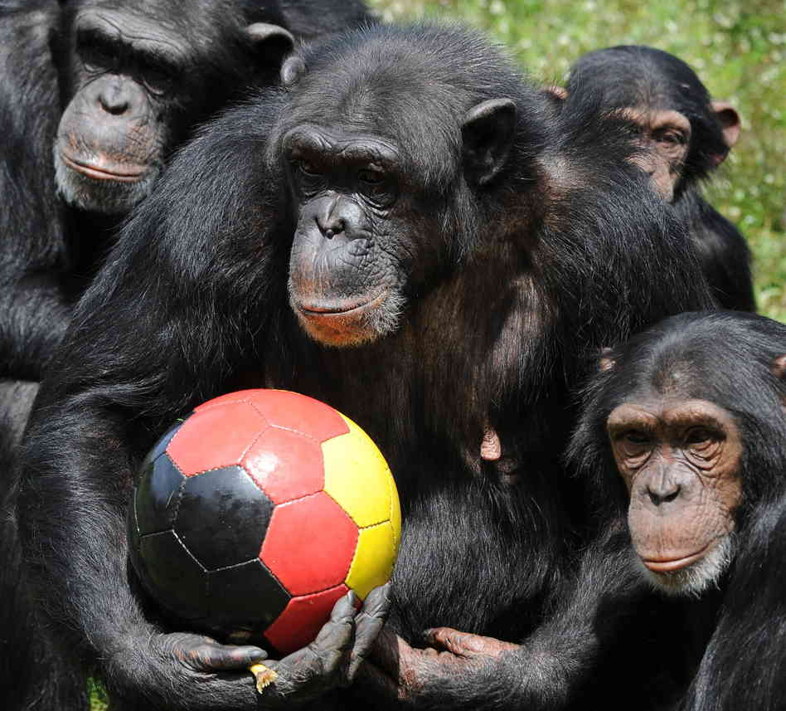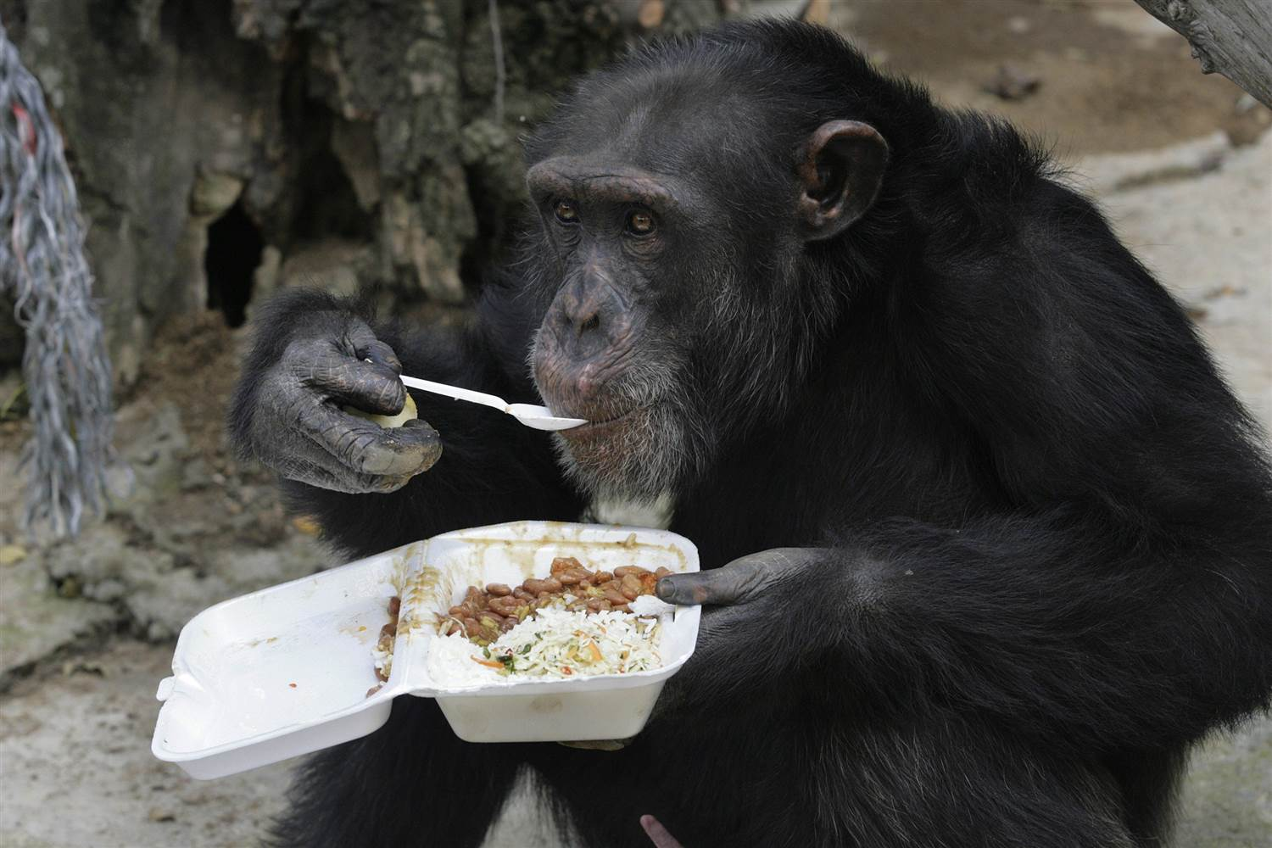Chimpanzees are clever, social animals. They live in groups, called “communities,” of up to several dozen animals. Chimps are omnivores, eating a varied diet of mostly fruit, vegetables, eggs, and insects, although they are known to eat other meats on occasion. They are frequently known as “cousins” to humanity, sharing about 98% of our DNA. Of course, the bananas that you buy at the grocery store share about 50% of our DNA, which only goes to show that creatures in related ecosystems are bound to share a certain amount in common. Also like ourselves, chimpanzees are taught life skills, including tool use, when they are young, by their parents and others in their community. Mostly unlike ourselves, however, young chimps seem to accept guidance and discipline from their elders easily, without the rebellion that seems to mark our interactions. They make a good example for those seeking wisdom. God has given us the opportunity, “built the house,” as it were, but we must still seek after wisdom and answer His invitation, as these animals do with their families.