and looked forward in faith to the time when such labor and corruption would come to an end. His hope that the promise might be realized in his son was not fulfilled, at least not as he was expecting. Nevertheless, Noah was destined to proclaim a bold warning against evil and to play an important role as the progenitor of all who have lived since his time.
- Verse 32: “Noah was five hundred…” In Hebrew this expression reads “Noah was a son of 500 years,” meaning that Noah was in his 500th year. Strictly speaking, “son of one year” means within the first year of life, so Noah, in his 500th year, had yet to reach his 500th birthday.
- Verse 32: “And Noah begat Shem, Ham, and Japeth.” From the sequence of names given here, one might naturally assume that Shem was Noah’s eldest, and Japeth the youngest. But this is incorrect. According to Genesis 9:24, Ham was the youngest. Genesis 11:10 indicates that Shem was 100 years old 2 years after the Flood, when Noah was in his 602nd year, suggesting that Shem was born when Noah was in his 502nd year, not the 500th as this text indicates. Thus the eldest must be
Read Genesis 5:1—Genesis 5:32
See also:
- Read Patriarchs and Prophets, Chapter 6: “Seth and Enoch”
Notes on Chapter 5:
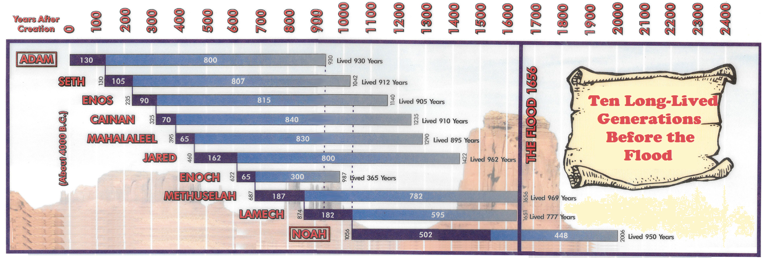
- Verse 22-24: “And Enoch walked with God…” The statement that “he walked with God” after his son’s birth does not imply that Enoch had been a godless person before. He belonged to the line of the faithful, and had doubtless been a loyal servant of the Lord during the first 65 years of his life. But with the arrival of his son, Enoch found, as do many parents, that he gained a new understanding of the depth of a father’s love. Note that the Biblical record here is irrefutable evidence that the states of matrimony and parenthood are in accord with a life of true holiness. After the birth of his first son, Enoch was drawn to God in a new way, and eventually was translated without seeing death. So far as we know, Enoch was the only antediluvian believer to be taken in this way. As a paragon of virtue, Enoch, the “seventh from Adam” stands in sharp contrast to the seventh generation of the Cainite line, Lamech, who added the crime of murder to the vice of polygamy. Enoch’s departure was witnessed by some of both the righteous and the wicked, as described in Patriarchs and Prophets, pg. 88. The translation of Enoch was designed by God, not only to reward the piety of a Godly man, but to demonstrate the certainty of God’s promised deliverance from sin and death. The memory of this remarkable event has survived in the Jewish tradition, the Christian record, and even in heathen tales. The Apocryphal “Book of Enoch” describes him as exhorting his son, and Arabic legends have made him the inventor of writing and arithmetic. His departure must have made a tremendous impact on his contemporaries, as evidenced by these accounts. Enoch’s exemplary life of faith testifies in our day of the possibility of living in a wicked world without being “of” it.
- Verse 29: “This same shall comfort us…” In the hope that his first-born son would be the promised Redeemer, Lamech called him Noah, meaning “to rest” or “to comfort.” Lamech was a faithful servant of God, following in the footsteps of his exemplary grandfather and long-lived father. He apparently felt the burden of tilling the ground that God had cursed,

Japeth, followed by Shem and then Ham. Shem is mentioned here first because of his importance as the progenitor of the postdiluvian patriarchal line of the chosen people. That’s why Noah is listed at 502 years old at the birth of his son (Shem) on the previous chart. Ham is mentioned next as the forefather of races with whom the Israelites had frequent contact, whereas the descendants of Japeth inhabited more remote regions. This same principle is repeated in Abraham’s case, where he, the youngest of his brothers, is mentioned first on account of his greater importance to those for whom the record was written.

