Genesis 10:1—Genesis 10:32
Note in particular the story of Nimrod.
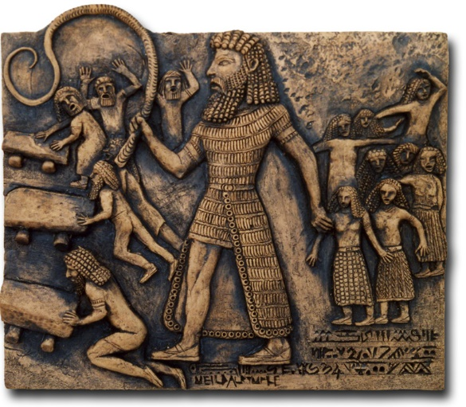
Nimrod was renowned for bold and daring deeds, but the expression “mighty one” may also include the connotation of “tyrant.” The LXX renders the phrase “before the Lord” as “against the Lord.” Although Nimrod acted in defiance of God, his mighty deeds made him famous among his contemporaries, and in future generations as well. Babylonian legends about Gilgamesh, who appears frequently on Babylonian reliefs and cylinder seals, as well as literary documents, may possibly refer to Nimrod. Verse 10 speaks of “the beginning of his kingdom.” Nimrod appears in the register of nations as the author of imperialism. He is the first man mentioned in the Bible as the head of a kingdom, and his first kingdom was Babylon.

