Genesis 23:1—Genesis 23:20
Characters and Motivations: References:
ABRAHAM:
- Wanted to buy a burial site for Sarah
- Wanted to be extremely polite to his neighbors, not pressuring them in any way
- Wanted to maintain a reputation as an honest businessman
EPHRON:
- Wanted to make good money by selling the field as well as the cave
- Wanted to be respectful of Abraham
Where were Abraham and Sarah living at the time of her death?
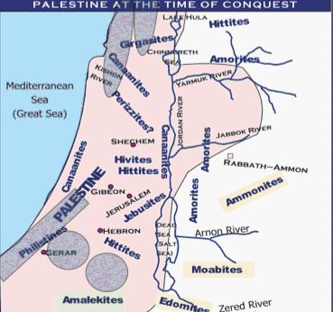
They were living near Mamre, close to Hebron, where they had been previously. It is some distance between Gerar, where Abimelech ruled, and Hebron. Abraham had moved back to his former home, near Hebron. Having lived for almost 40 years in the land of the Philistines, he now returned to Canaan proper.
What can we learn from Abraham’s approach to his neighbors in verses 3-4?
Abraham frankly admitted his status as a sojourner, and made no claim to any of the land by right. God had promised him all of Canaan. With hundreds of his men, he had defeated the allied expeditionary force from Mesopotamia. These very Hittites recognized him as a “mighty prince.” Yet, in humility, Abraham did not present his neighbors with a demand. Instead, he requested permission to secure title to a piece of land, not by right, but as a favor and for a price.
How do the “children of Heth” respond?
They respond with great courtesy. Declining to accept his own appraisal of his status, they acknowledge him as a mighty prince. They even offer to make their own burial places available to him, which is a truly courteous gesture.
Why did Abraham address the “people of the land” instead of asking Ephron, who was clearly present?
This is Oriental courtesy, requesting the elders of the city to use their influence in securing the desired property. They were to be his go-betweens in the transaction. Such a procedure would result in conducting the agreement with greater dispatch, and would also avoid potential misunderstandings. The good name of the entire community would ensure a reasonable deal, and protect both participants.
Is Ephron’s offer to give the land to Abraham sincere? What is its purpose?
This offer follows a good Eastern custom that has been kept alive in some places to this day. Everyone knew, of course, that the offer was not meant seriously. Ephron was unwilling to sell the cave without the field. The reason for this lies in the Hittite laws, which call for taxes to be paid unless the whole property is sold. Thus, if Abraham had purchased the cave alone, Ephron’s taxes would remain the same, but his purchase of the whole property would transfer the tax burden to Abraham.
Observations: References:
- The name of the cave, “Machpelah,” has been explained in various ways. Some have taken it as a proper name, others as descriptive of some characteristic of the cave. It may be from the root “kaphal,” meaning “to double,” suggesting a double cave, or perhaps one with two entrances.
- Ephron’s price of four hundred shekels is perhaps about $116 dollars today. Although this price appears very reasonable to us, it must have seemed a bit exorbitant to Abraham. According to Babylonian records, fields were sold at about 4 shekels an acre, and the most fertile gardens at 40 shekels an acre. Though we don’t know how large Ephron’s field was, it seems dubious that it was a 100 acre parcel of land. Moses seems to leave the impression that Ephron took advantage of Abraham’s predicament to make a good profit for himself.
- The final verse of the chapter emphasizes that Sarah found her last resting place in a piece of ground belonging to Abraham in the promised land of Canaan.
We know that “All scripture is given by inspiration of God, and is profitable for doctrine, for reproof, for correction, for instruction in righteousness: That the man of God may be perfect, thoroughly furnished unto all good works.” 2 Timothy 3:16-17. How does this apply to these verses? Why is this information recorded? What are we meant to draw from it? Why has God provided us with these specific words?
Here we see in even finer detail the exquisite courtesy that Abraham had for his neighbors. It is a wonderful example that, even at this terrible time of grief, the patriarch cared deeply for the feelings of his fellow men.

