Genesis 28:1—Genesis 28:22
See also:
- Read the first few pages of Patriarchs and Prophets, Chapter 17: “Jacob’s Flight and Exile”
Characters and Motivations: References:
ISAAC:
- Must have been angry with Jacob after the events of the last chapter, but he still loved Jacob and gave him his blessing before sending him to seek a wife from his mother’s family
- Confirmed Jacob’s position as heir
JACOB:
- Probably afraid of Esau, who had promised to kill him
- Obedient to his parent’s wishes regarding a bride
- Was awed by God’s direct communication to him, and eager to commemorate the remarkable experience
- Began to appreciate the meaning of a personal relationship with God—including his part in that relationship
ESAU:
- Began to recognize that he had some issues—in particular, regarding his wives—but sought to fix them by external rather than internal means
How do you suppose Isaac, Rebekah, Jacob and Esau’s family life has changed since the dramatic events of the last chapter? Do you see any evidence of changes here?
There must have been some changes. Jacob was now the established heir. The tension between the twins had escalated from trickery and manipulation to planned fratricide. The tension between Isaac and Rebekah must also have shifted. They were previously in contention over who should be named as the heir, and that had been resolved.
In the blessing that Isaac gave to Jacob before his trip, Isaac appears to have accepted Jacob’s position as the heir. This new clarity may have made Esau increasingly aware of his parents’ disapproval of his marriage(s), which led him to take another wife.
Consider the story in verse 9. What does this tell you about Esau?
Esau seems to have really wanted to please his father, but he didn’t really want to change. He wanted to make his outward circumstances more closely resemble his parents’ desires, but he didn’t really desire to change.
Verses 12-15 describe Jacob’s dream as he traveled. What was this dream? What was its significance?
Jacob saw a connection between us and heaven, angels carrying business between both places. Then God spoke to him, introducing Himself and repeating the promises that were given to Abraham.
The ladder was a visible symbol of the real and uninterrupted fellowship between God in heaven and His people on earth. The angels ascend to present men’s needs before God, and descend with promises of divine assistance and protection. Then God proclaimed Himself directly to Jacob as the God of his fathers. He not only confirmed to Jacob all the promises made to his forbearers—the possession of Canaan, numerous descendants and so forth—but also assured him of protection on his journey and a safe return home.
How does Jacob react to this dream? Why?
Firstly Jacob is astounded at God’s closeness. He had, through lack of faith, thought himself alone, but his dream revealed that God was “in this place.” Those who are accorded the privilege of a revelation of God feel a sense of profound awe. To Isaiah game a conviction of guilt so intense that he feared for his life (Isaiah 6:5). Similarly, this experience brought to Jacob a keen realization of his unworthy and sinful state. His exclamation, “how dreadful is this place!” reveals the intensity of his new awareness. This leads him to take action. First, he sought to commemorate this event by setting up a memorial stone. Secondly, in profound appreciation of God’s promises, Jacob “vowed a vow,” that is, he committed himself personally to God. Jacob had thought of God as the God of his fathers. To be sure, he had believed in God, but in a distant and secondary way. Now he finds a much more personal and real reliance on God, a committed two-way relationship.
Observations: References:
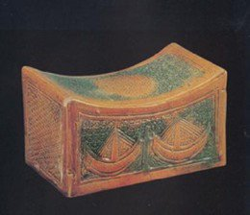
- “His pillows,” (v. 11). Literally, “the region of his head.” Jacob took a stone and put it under his head, as a headrest. A pillow in our sense of the word seems to have been unknown to the ancients. In many Oriental lands people used headrests of wood, clay, stone, or metal, and still do. Many ancient examples of these have been preserved in Egypt. It was therefore no hardship for Jacob to sleep with his head on a stone.
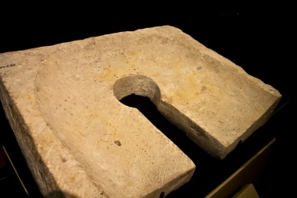
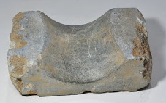
- “The tenth,” (v. 22). Abraham and Jacob both understood and practiced payment of tithe. Jacob’s words imply that this had not been his habit in the past. Perhaps he had had little to call his own—as opposed to his father’s. Perhaps his grasping spirit had led him to be careless in tithing what was his. In any event, he vowed henceforth to pay his tithe faithfully, not to earn the favor of Heaven, but in humble and grateful recognition of the pardon and favor of God.
We know that “All scripture is given by inspiration of God, and is profitable for doctrine, for reproof, for correction, for instruction in righteousness: That the man of God may be perfect, thoroughly furnished unto all good works.” 2 Timothy 3:16-17. How does this apply to these verses? Why is this information recorded? What are we meant to draw from it? Why has God provided us with these specific words?
This is a great example of real commitment, especially for those of us who have been Christians for years. The secondary “God of my fathers” kind of belief which features little to no real action or true commitment isn’t enough for someone who really wants the Lord to be their God. Interestingly, it is in the small things like honest tithing that this active type of faith is noted.

