Genesis 36:1—Genesis 36:43

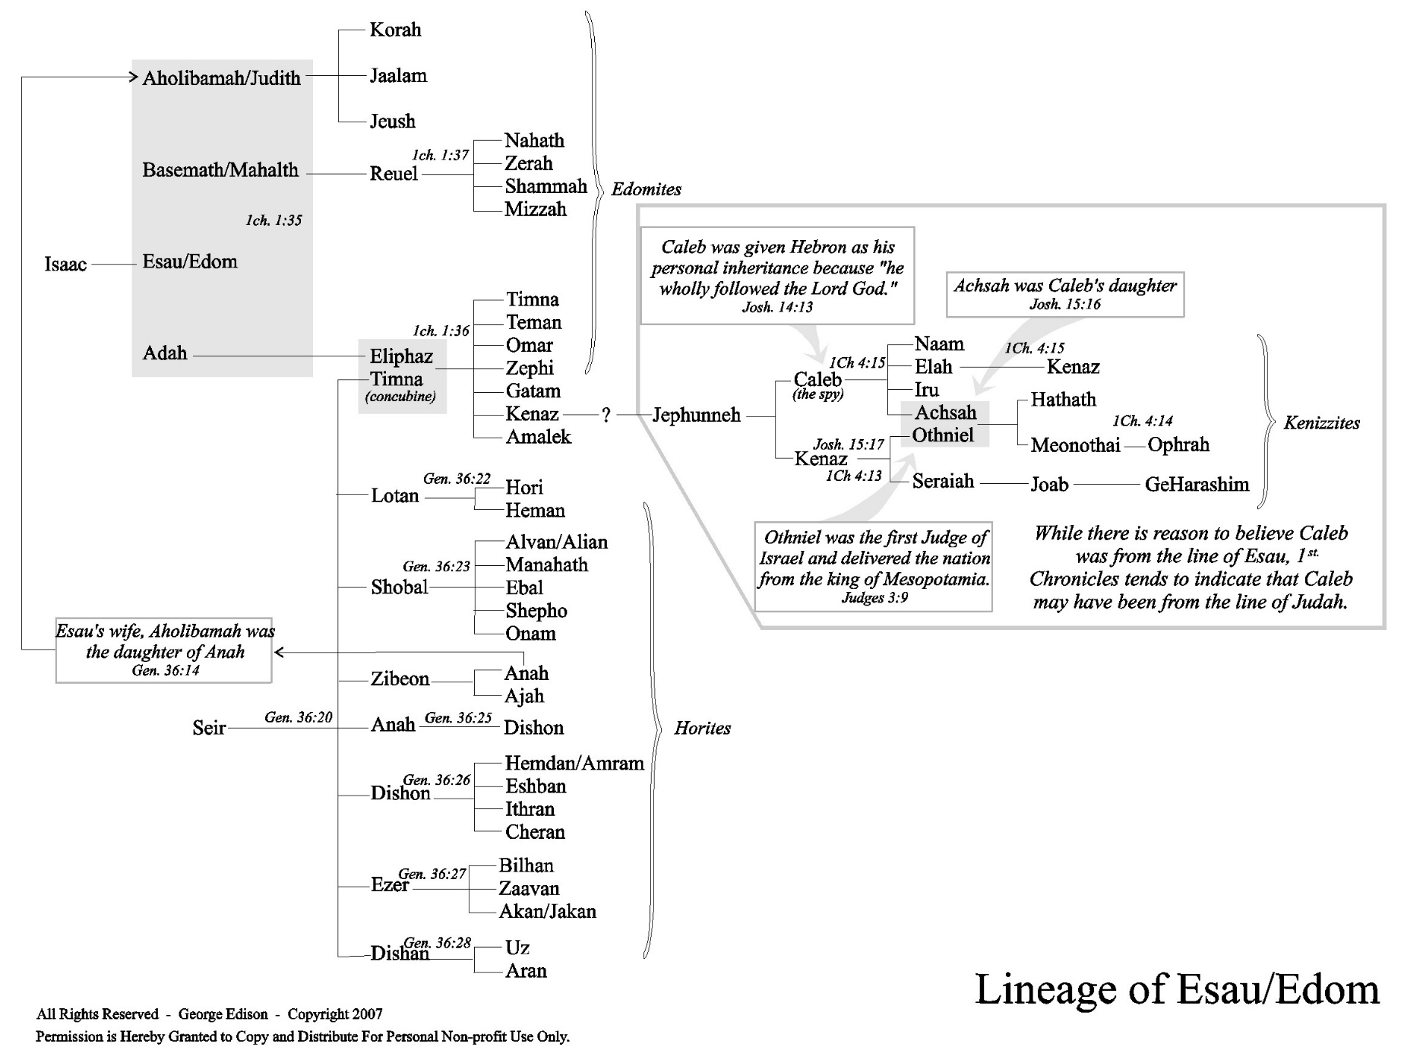

The names of Esau’s wives:
The names of Esau’s wives as given here differ from those of the previous list. In one instance the father’s name and nationality vary also. But these differences are easily accounted for. In ancient times, people’s names changed when they encountered an important experience or event. As a rule, women received new names at marriage, a custom that would account for the differences here. In the case of Judith and Aholibamah, the father’s name and nationality differs as well. As a rule childless wives are not mentioned in genealogies, so it can be inferred that Judith died childless and Esau married Aholibamah in her stead.
The dukes:
The Hebrew word translated here as “duke” is more accurately rendered “prince,” or “chief,” and was apparently a title taken by Edomite and Horite tribal leaders. These leaders were often contemporary with one another.
The sons of Seir:
The original inhabitants of the land were Horites. They were scattered far and wide over the ancient East during the second millennium BC. Their language has been recently deciphered, and much is now known of their culture and history. Seir’s descendants mingled with Esau and his descendants.
The mules:
Moses supposes that the event recorded in verse 24 is well known, but this is the only mention of it that we have. The meaning of the word yemim, translated here as “mules,” is uncertain. Some commentators think that it refers to hot springs instead. Three such springs are known in the general region.
The Edomites:
In later years, the Edomites became traditional enemies to the Israelites. Even though Esau reconciled with Jacob, their descendants fought for hundreds of years.

