Genesis 44:1—Genesis 44:34
Characters and Motivations: References:
JOSEPH:
- Was determined to test his brothers’ feelings, especially toward Benjamin
JUDAH:
- Already feeling guilty for the grief that he had caused his father, Judah wanted to prevent the loss of Benjamin
- Does not appear to hold the same resentment against Benjamin as he did against Joseph
Why does Joseph trick his brothers by hiding the cup? Why does he choose Benjamin’s sack?
This was Joseph’s final and decisive test before revealing himself to his brothers. He wanted to create a situation where his brothers had a legitimate excuse to rid themselves of their father’s favorite, as they had previously, and examine their reaction. Either they would eagerly consent to Benjamin’s slavery in Egypt or they would do everything in their power to prevent such a thing. Their choice would reveal beyond a doubt what kind of men they had grown to be.
Does Joseph in fact work magic and divination, as verses 5 and 15 imply? Why or why not?
The ancient Egyptians believed in a variety of methods of divination, including the existence of special goblets which were thought to be capable of detecting any poison placed in them. These were obviously thought to be extremely valuable. But the fact that the steward was instructed to mention the practice of magic does not imply that Joseph had actually adopted such practices himself. On account of his great wisdom, the Egyptians probably attributed to Joseph the practice of magic. From their perspective, he certainly had excelled their court magicians in dream interpretation and predicting the future. Perhaps his fame as a wise man had spread far and wide, even to foreign lands, so that the supposed thieves of the goblet might appropriately be asked whether they were unaware of this fact. But Joseph himself is consistently represented in the Bible as faithful to the beliefs of his fathers. This would be very inconsistent with the practice of Egyptian magic and divination. Therefore it is reasonable to assume that although Joseph was willing that his brothers should (temporarily) believe that he was able to read their thoughts and divine their actions for the purposes of his test, he had not actually adopted Egyptian practices of magic and divination.
How do Joseph’s brothers defend themselves against the charge of theft? What do they suggest as punishment? Why?
The brothers claim, logically enough, that they had attempted to return the money that had reappeared in their sacks on their first trip to Egypt. They were therefore not thieves and had no motivation to steal a valuable goblet. Conscious of their complete innocence, they did not hesitate to pronounce the most severe penalty on the thief. These rash words seem a bit foolish, particularly after the experience of finding their money mysteriously placed in their bags. But the friendliness with which they had been received and entertained by Joseph had disarmed their suspicions.
When Joseph proposes that Benjamin remain as a slave in Egypt, Judah begs otherwise. What is his reasoning? What is his solution? Compare Gen. 37:26-27. What can we conclude about Judah from this speech?
Interestingly, Judah does not proclaim Benjamin’s innocence. He probably assumed that he would not be believed. Instead he freely acknowledges the brothers’ collective guilt. He is referring, of course, to the crime committed against Joseph. But to the Egyptian bystanders, particularly the steward, his words meant the acknowledgement of their guilt in taking the goblet. This must have astonished the Egyptians, since they knew that the men were really innocent. Then Judah reminds Joseph of the circumstances of Benjamin’s trip to Egypt—specifically that it was something that Joseph himself had insisted on. Then he proceeds to depict in affectionate and effective words the love of their father for the son of his old age, and his grief if they returned without him. Instead, Judah suggests that he himself remain in Benjamin’s place. Judah’s self-sacrifice is certainly deserving of praise. Voluntary submission to servitude on behalf of a brother who enjoyed a higher degree of parental affection, in order to save his father fresh sorrow and anguish, cannot be overestimated. Judah emerges here as a truly converted man, a worthy ancestor of the promised seed, and worthy to give his name to the chosen people of God. Joseph could not doubt that true and lasting change had come over his brothers, and over Judah in particular, since the day when he had eagerly urged the sale of Joseph into slavery.
Observations: References:
- The brothers’ brutal judgement on the theoretical thieves was a rash statement. But the steward declined to think of punishing the innocent with the guilty, or even the guilty as harshly as they suggested. When others speak rashly we should not take advantage. We ourselves may at times make commitments without due deliberation which may bring injury to us, except for the leniency of others.
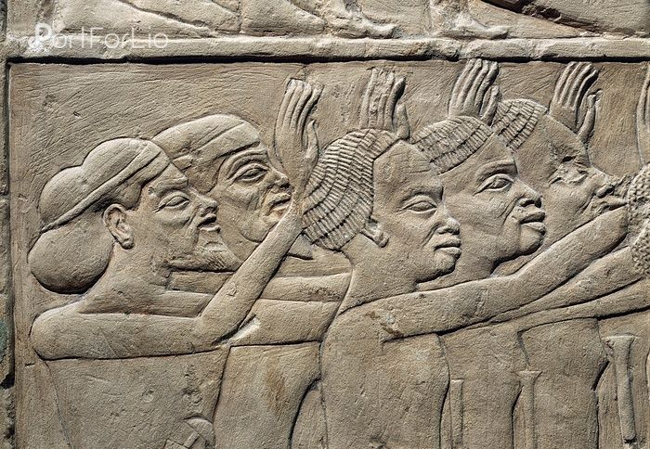
- With Judah leading the way, the brothers returned to Joseph’s house after the discovery of the cup. There they all fell down before Joseph, pleading for mercy. Several ancient reliefs depict similar situations.
- Judah’s remark in verse 27 implies that Jacob regarded Rachel as his only actual wife, even though he was also married to Leah. Certainly Bilhah and Zilpah were never considered as actual wives—just concubines.
- Judah apparently believes, with his father, that Joseph is dead. He implies in verse 28 that Joseph, had he been alive, would certainly have been able to return or send word. Never having seen him since the day of his forced departure, Judah could only conclude that his fears were fully justified.
We know that “All scripture is given by inspiration of God, and is profitable for doctrine, for reproof, for correction, for instruction in righteousness: That the man of God may be perfect, thoroughly furnished unto all good works.” 2 Timothy 3:16-17. How does this apply to these verses? Why is this information recorded? What are we meant to draw from it? Why has God provided us with these specific words?
Joseph is a brilliant tactician. He has set up the perfect test to reveal his brother’s truest motives—and they aren’t even aware of what he’s testing. It’s a perfect test. The only possible way to set up a situation so flawlessly is with God’s guidance. He is the only one with an adequate understanding of all the characters involved. This should teach us how much God is involved with all aspects of our lives, and how much a close relationship with Him is necessary in all parts of our lives.

