
Topic: Joshua 3:1-17
Discussion on: 2/24/21
Commentary (Katie)

- Consider the instructions provided in verses 2-4. Why were these instructions given?
Many things were about to change for the Israelites. They would eat differently, as the manna no longer fell. The pillar of cloud and fire which had physically guided them through the wilderness would disappear. The Lord, of course Jordan, the Israelites would enter a new chapter of their history. Accordingly, they were given detailed instructions. The ark, which had formerly been in the midst of the camp, was to lead the way across the Jordan. It was the center of their religion and a symbol of God’s presence. Thus the Lord was with them still, though no longer in the pillar of cloud. To impress upon the Israelites the fact that it was God who gave them entrance into Canaan, and who would lead them in its conquest, His presence was to go before them. To make this work, the ark needed to be visible to everyone. It was necessary that the entire company of Israel see the ark, since the pillar of cloud no longer led them. The distance between the ark and the people made it possible for many more to observe the rolling back of the Jordan than if it had been closely followed by a throng of people. Had many people been permitted to crowd around the ark, it would soon have been lost to the sight of the great majority. This space also emphasized reverence and respect for the ark and God’s law. Whenever we enter a new path, we also need to focus on respect for God’s law.
- What must the people do before they enter Canaan (v. 3-5)? Why?
Joshua tells them to “sanctify” themselves. Probably they were to wash themselves and their garments, and to abstain from everything that might prevent them from fixing their attention on the great miracle soon to be played out before them. It’s important to note that humans don’t really have the ability to sanctify themselves! But the blessing of God attends preparations that are made to honor Him, and He provides the sanctity. Thus we can be said to sanctify ourselves as long as we put sincere efforts to please Him into our preparations. People must cooperate with God in the working out of their own salvation (Phil. 2:12). It’s worth noting that if we want God’s blessing in our own preparations for entering the heavenly Canaan, it is essential that we sanctify ourselves by consecrating our lives to God. If this was necessary for entering into the earthly Canaan, it must be absolutely necessary for admission to the heavenly Canaan.
- What does God promise in verses 7-8? What are His directions?
Crossing the Jordan would do for Joshua what the giving of the law at Sinai did for Moses. Both men were established before the people because they were first established with God. We must work on our connection to God first. Everything else will fall into place based on that! Why did the Lord have Israel wait until Jordan was in flood stage before crossing it? A month earlier or a month later this would not have been so, and they had been encamped at Shittim for two months. This way His power was much more evident. Also, the people in Jericho were not expecting the Israelites to cross at this time, so they wouldn’t have guarded the river. The people of Jericho remembered well the report of Israel crossing the Red Sea, and this second miraculous crossing struck even greater terror into their hearts. The directions were for the priests to enter the shallow water at the edge of the Jordan River, demonstrating their faith that God would stop the water. When the water had ceased flowing, they were to proceed to the middle of the river and remain there until all Israel had passed over.
- What happened when the priests carrying the Ark stepped into the edge of the Jordan River?
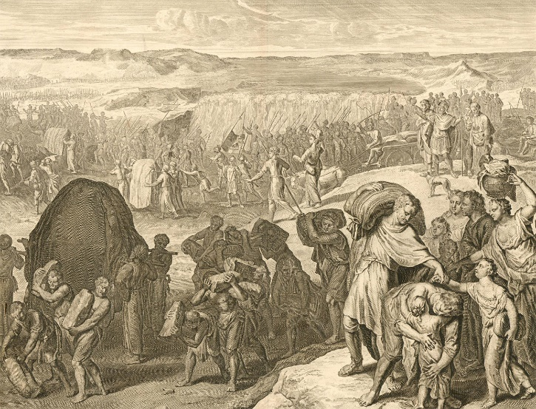
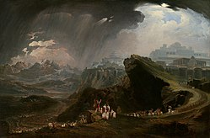
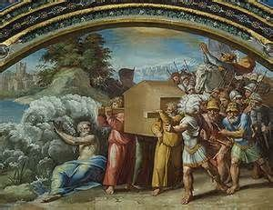
The waters flowed on and left the whole river bed dry, from a point above the ark down to the Dead Sea. This was a distance of several miles, and provided ample room for the multitude of people, with their cattle, to pass over quickly. The waters themselves “stood and rose up upon an heap.” I have really no idea what this looked like, although I have certainly tried to imagine it. As indeed have various artists! The miracle of the Red Sea, the opening of a path through raging water, is here repeated as evidence that God has the same power to complete the salvation of His people as He had to begin it.
- What did the people do? Why?
The people “passed over right against Jericho.” Of course, it would have been difficult if not impossible for the whole camp to pass over at one spot. They probably made use of several miles of the bed of the Jordan. The priests with the ark evidently crossed opposite Jericho, and the multitude passed over on both sides of the ark. It is likely that the Canaanites would have attempted to defend the fords of the Jordan if they had expected such a passage would be attempted. They surely knew that the Israelite camp was on the other side of the Jordan, but the unseasonable crossing took them entirely by surprise.
APPLICATIONS TO MY LIFE:
It must have been difficult for the Israelites to lose the visible evidence of God’s guiding hand—the pillar of cloud and fire. They were entering a foreign and hostile land without the leadership of Moses, who had led them for so long. Now they were to lose both the guiding pillar and the daily reassurance of manna. If their faith wavered, they would certainly be afraid of such changes. But they had directions to follow. They were to sanctify themselves and follow the ark: the law covered with mercy. We struggle with new paths also. There are always new challenges to face. But regardless of the difficulty, we must persevere, and we have the same directions to follow: sanctify ourselves, and follow the law, embracing His mercy for ourselves and practicing His mercy with others.

