
Topic: Joshua 6:1-27
Discussion on: 3/17/21
Commentary (David)

- Consider verses 1-2. What does this say about Jericho? Why?
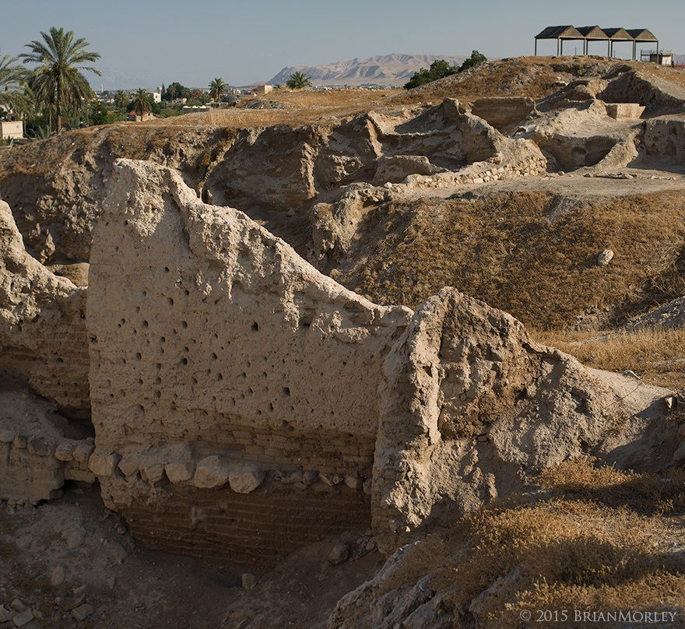
Jericho was “straitly shut up,” meaning that the gate was more than just shut. It was also securely fastened with bolts and bars. The outcome of the divine prediction is so sure that it is stated as already having happened. The Lord is saying that “I have already given you Jericho, and the king, and the mighty men of valor” even before the battle takes place.
The people of Jericho have already heard about the divine miracle of the Red Sea crossing, and now they see the miracle of the Jordan River crossing in person. The Amorites know that the Israelite God led the people through the Jordan River, and that the God of Israel could easily lead them to victory over Jericho also.
- How, exactly, will Jericho be conquered?
Jericho will be conquered by faith and not by any action of the people but of the Lord alone. The people will learn through following the directions of the Lord to solemnly march around the city with the chosen men of war leading, then seven priests bearing trumpets, then the Ark of the Covenant borne by priests, and last of all, the army of Israel made up the rearward. And they were to march around the city each day for six days. Then on the seventh day, they were to go around the city seven times. On the seventh time, the priests were to blow the trumpets for a long blast signaling the people to shout with a great shout. By following these directions, the people learned patience in God’s plan. And through cooperation with God’s plan, they gained faith in God through obedience.
- What is the “seventh day” referenced in verse 15? What about Sabbath? At least one of the seven days had to be a Sabbath. Why would they perform such activity on Sabbath?
The term “seventh day” refers to the last day in the circuits made around the city. At least one of the days fell on Sabbath. The activities that they performed were not of their own choosing, they were being led by God in these activities, so it had to be correct to do them on Sabbath.
- What was to be taken from Jericho? Why?
Silver, gold, vessels of brass, and iron are to be taken from Jericho. They were to be taken as the first fruits of Israel’s conquest, dedicated to God, and put in His treasury. Nothing was to be taken from Jericho for personal gain and all living things utterly devoted to destruction.
- What happened to Rahab and her family?
Rahab and her family were saved by Joshua when he sent in the two spies to find Rahab and bring her out. They were then kept without the camp of Israel. In doing so they were instructed in the religion of Jehovah and had purified themselves from their heathen ways and beliefs from coming into the camp.

APPLICATIONS TO MY LIFE:
TBD

