
Topic: Joshua 8:1-35
Discussion on: 4/7/21
Commentary (Martin)

- This is Israel’s second attack on the city of Ai. What is different this time?
- The Lord said arise and go up. Do not be afraid you will take the city. I have given Ai to you.
And the LORD said unto Joshua, Fear not, neither be thou dismayed: take all the people of war with thee, and arise, go up to Ai
- Dismayed. The sin of Achan and its consequences must have brought great discouragement to Joshua. But now that he had done God’s will in ridding the camp of sin, the Lord gave him fresh encouragement to proceed with the conquest.
Take all the people. The spies had suggested that Joshua not require all the people to participate in the attack on Ai (ch. 7:3), and he had acceded to their suggestion. Human wisdom, guided by over-confidence, dictated this first plan and it failed. Now it seems that God administered a tacit rebuke to the scheme of partial participation. He directed that all were to share in the task of taking Ai, and to receive a portion of the spoils. Thus it is in the cause of God today. All are to labor in the work of the gospel, and all are to share in its rewards.
- Lay thee an ambush. God Himself gives detailed instruction as to strategy to be employed. Joshua should have waited for such divine direction before pressing his first attack. Often we too run ahead of God, and walk in the sparks of our own kindling (see Isa. 50:11), all the while thinking that we are doing the will of God. In every decision in life we should earnestly inquire, Is this the will of God?
- How exactly did Joshua arrange his forces? Can you draw a diagram?
3 So Joshua arose, and all the people of war, to go up against Ai: and Joshua chose out thirty thousand mighty men of valour, and sent them away by night. 4 And he commanded them, saying, Behold, ye shall lie in wait against the city, even behind the city: go not very far from the city, but be ye all ready: 5 And I, and all the people that are with me, will approach unto the city:
12 And he took about five thousand men, and set them to lie in ambush between Beth-el and Ai, on the west side of the city. 13 And when they had set the people, even all the host that was on the north of the city, and their liers in wait on the west of the city, Joshua went that night into the midst of the valley.

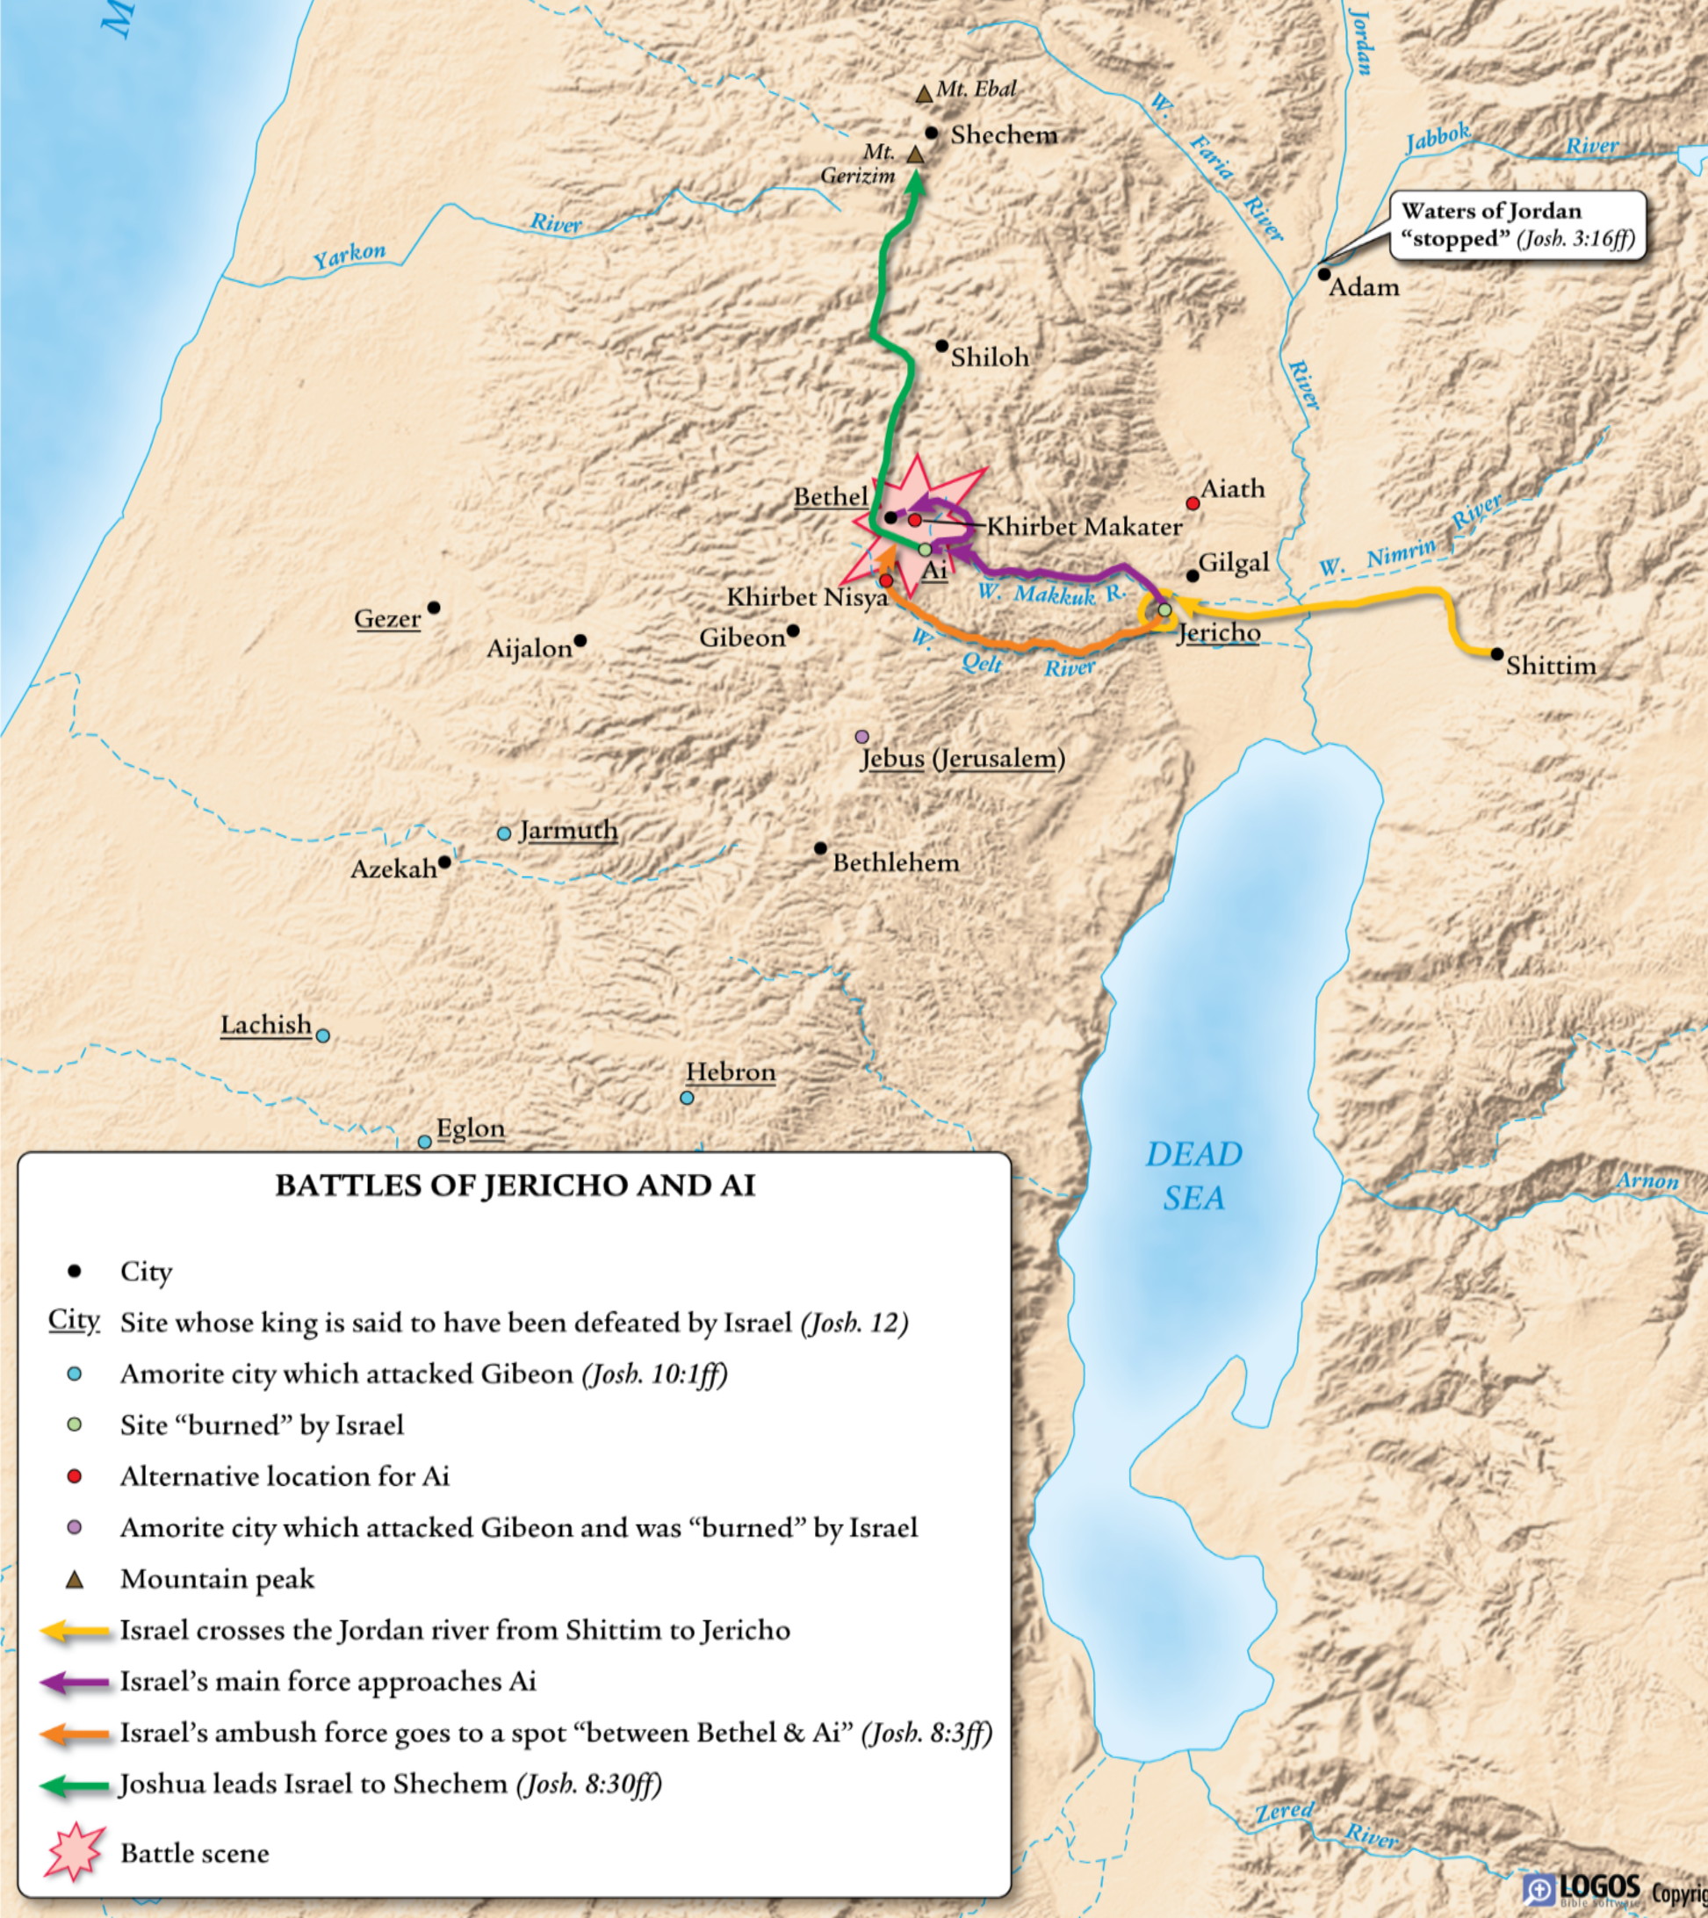
3. What was the plan for taking the city?
and it shall come to pass, when they come out against us, as at the first, that we will flee before them, 6 (For they will come out after us) till we have drawn them from the city; for they will say, They flee before us, as at the first: therefore we will flee before them. 7 Then ye shall rise up from the ambush, and seize upon the city: for the LORD your God will deliver it into your hand. 8 And it shall be, when ye have taken the city, that ye shall set the city on fire: according to the commandment of the LORD shall ye do. See, I have commanded you
- After the victory at Ai, where did the Israelites go? Why? See also Patriarchs and Prophets, Chapter 46.
Before taking possession of their inheritance, they must renew their covenant of loyalty to God. In the last instructions of Moses, direction had been twice given for a convocation of the tribes upon Mounts Ebal and Gerizim, at Shechem, for the solemn recognition of the law of God. In obedience to these injunctions the whole people, not only men, but “the women, and the little ones, and the strangers that were conversant among them” left their camp at Gilgal, and marched through the country of their enemies, to the vale of Shechem, near the center of the land. Though surrounded by unconquered foes, they were safe under the protection of God as long as they were faithful to Him. Now, as in the days of Jacob, “the terror of God was upon the cities that were round about them” (Genesis 35:5), and the Hebrews were unmolested.
- Who was present for this event? Why? What does this mean for us?
Before taking possession of their inheritance, they must renew their covenant of loyalty to God. In the last instructions of Moses, direction had been twice given for a convocation of the tribes upon Mounts Ebal and Gerizim, at Shechem, for the solemn recognition of the law of God. In obedience to these injunctions the whole people, not only men, but “the women, and the little ones, and the strangers that were conversant among them” left their camp at Gilgal, and marched through the country of their enemies, to the vale of Shechem, near the center of the land. Though surrounded by unconquered foes, they were safe under the protection of God as long as they were faithful to Him. Now, as in the days of Jacob, “the terror of God was upon the cities that were round about them” (Genesis 35:5), and the Hebrews were unmolested.
The spot chosen was one of the most beautiful in all Palestine, and worthy to be the theater where this grand and impressive scene was to be enacted. The lovely valley, its green fields dotted with olive groves, watered with brooks from living fountains, and gemmed with wild flowers, spread out invitingly between the barren hills. Ebal and Gerizim, upon opposite sides of the valley, nearly approach each other, their lower spurs seeming to form a natural pulpit, every word spoken on one being distinctly audible on the other, while the mountainsides, receding, afford space for a vast assemblage.
Israel had received the law directly from the mouth of God at Sinai; and its sacred precepts, written by His own hand, were still preserved in the ark. Now it had been again written where all could read it. All had the privilege of seeing for themselves the conditions of the covenant under which they were to hold possession of Canaan. All were to signify their acceptance of the terms of the covenant and give their assent to the blessings or curses for its observance or neglect. The law was not only written upon the memorial stones, but was read by Joshua himself in the hearing of all Israel. It had not been many weeks since Moses gave the whole book of Deuteronomy in discourses to the people, yet now Joshua read the law again.
John 4:20 ur fathers worshipped in this mountain; and ye say, that in Jerusalem is the place where men ought to worship
APPLICATIONS TO MY LIFE:
TBD

