
Read: Joshua 10:1-20
Prepare for: 4/21/21

- What is Adoni-zedec’s plan? What action does he take?
________________________________________________________________________________________________________________________________________________________________________________________________________________________________________________________________________________________________________________________________________________________________________________________________________________________________________________________________________________________________________________________________________________________
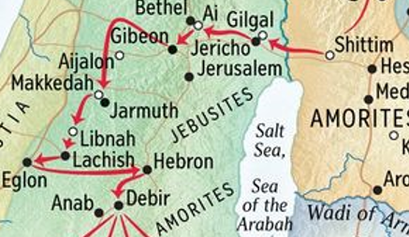
- Which kings/cities are involved here? Why?
________________________________________________________________________________________________________________________________________________________________________________________________________________________________________________________________________________________________________________________________________________________________________________________________________________________________________________________________________________________________________________________________________________________
- What happens in verses 12-14? Why?
________________________________________________________________________________________________________________________________________________________________________________________________________________________________________________________________________________________________________________________________________________________________________________________________________________________________________________________________________________________________________________________________________________________
- What is the “Book of Jasher?” Compare 2 Samuel 1:18-27 and 1 Kings 8:53. _______________________________________________________________________________________________________________________________________________________________________________________________________________________________________________________________________________________________________________________________________________________________________________________________________________________________________________________________________________________________________________________________________________________
- Why doesn’t Joshua pursue the five kings into the cave?
______________________________________________________________________________________________________________________________________________________________________________________________________________________________________________________________________________________________________________________________________________________________________________________________________________________________________________________________________________________________________________________________________________________________________________________________________________________________________________________________________________________________
APPLICATIONS TO MY LIFE:

