
Read: Joshua 10:21-43
Prepare for: 4/28/21

- Consider verse 21. What’s going on here?
_____________________________________________________________________________________________________________________________________________________________________________________________________________________________________________________________________________________________________________________________________________________________________________________________________________________________________________________________________________________
- Verses 22-26 present a fairly gruesome picture. Why are they putting their feet on the necks of the captives?
_____________________________________________________________________________________________________________________________________________________________________________________________________________________________________________________________________________________________________________________________________________________________________________________________________________________________________________________________________________________
- What is going on with the smiting and slaying and hanging? Why such savagery?
________________________________________________________________________________________________________________________________________________________________________________________________________________________________________________________________________________________________________________________________________________________________________________________________________________________________________________________________________________________________________________________________________________________
- What is “All the country of the hills, and of the south, and of the vale, and of the springs”?
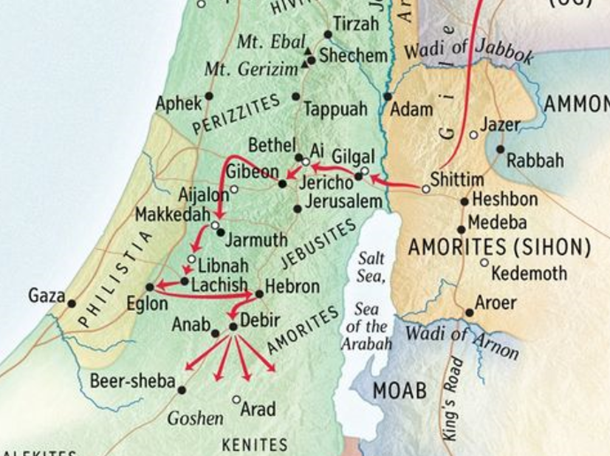
_________________________________________________________________________________________________________________________________________________________________________________________________________________________________________________________________________________________________________________________________________________________________________________________________________________________________________________________________________________________________________________________________________________________________________________________________________________________________________________________________________________________________________________________________________________________________
- This chapter doesn’t seem to fit the picture that we have today of “God’s people.” It seems rather aggressive—brutal even. What lessons, if any, should we take from this?
______________________________________________________________________________________________________________________________________________________________________________________________________________________________________________________________________________________________________________________________________________________________________________________________________________________________________________________________________________________________________________________________________________________________________________________________________________________________________________________________________________________________
APPLICATIONS TO MY LIFE:

