
Topic: Joshua 10:21-43
Discussion on: 4/28/21
Commentary (Katie)

- Consider verse 21. What’s going on here?
“All the people” returned to the camp in peace. That is, no Israelite was slain, none wounded, none missing from the battle. The Hebrew expressly states that against one single Israelite none dared lift up the voice, much less a weapon. It was a complete, glorious victory. The Israelites were involved, but it’s clear that God was really fighting the battle.
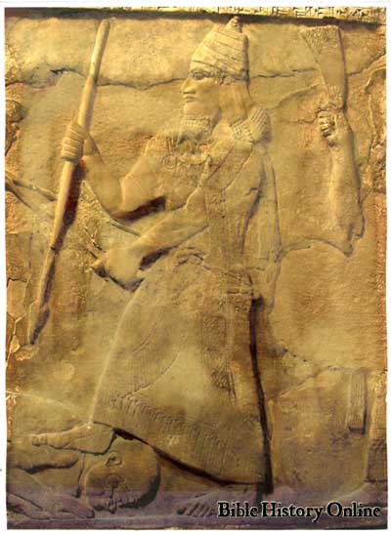
2. Verses 22-26 present a fairly gruesome picture. Why are they putting their feet on the necks of the captives?
These men were not merely enemies. They had placed themselves in direct opposition to God. And the dramatic picture provided by placing a foot on the neck of the captives demonstrates that the kings had been utterly defeated by the Israelites. This particular procedure was a custom of the orient, as can be seen from certain Assyrian and Egyptian monuments. To the Israelites it was a demonstration of the complete subjection to which God will reduce all their adversaries.
- What is going on with the smiting and slaying and hanging? Why such savagery?
The Hebrew people did not hang men alive in Old Testament times. The victim was first killed and then hanged by way of example, to deter others from similar crimes. This seems fairly horrible to modern sensibilities, but the Israelites were trying to conquer a country. There was no space here for debate or compromise. The Israelites could not afford to follow any procedure except the one that God had given them: they were to dominate this land and drive off all of the heathen peoples that currently occupied it. God had given the land of Canaan over to the Israelites. The current inhabitants needed to understand this fact. This methodology—while gruesome—made their intentions entirely clear to everyone.
- What is “All the country of the hills, and of the south, and of the vale, and of the springs”?
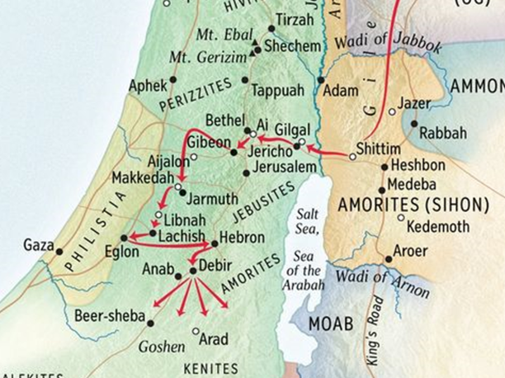
The expression “the hills” denotes the mountainous region extending southward from Jerusalem. The south is a semi-arid region of limestone. The vale is a lowland, also called the Shephelah, a foothill region between Judah and Philistia. The springs probably refers to the undulating land at the foot of the Shephelah, between it and the plain of Philistia. This region was intersected by brooks and ravines, and so fertile and prosperous.
5. This chapter doesn’t seem to fit the picture that we have today of “God’s people.” It seems rather aggressive—brutal even. What lessons, if any, should we take from this?
When God gives directions, there is no time for half measures! The Israelites are invading a country. They are undoubtedly going to be looked upon as the aggressors in this situation. The Canaanites will probably not consider their actions to be very kind. And that whole stepping on the necks of their enemies seems impolite at a minimum. Curiously, none of that matters. The Israelites, as God’s people, are following God’s directions. Even if those directions don’t seem particularly kindly. Even if those directions are politically incorrect. Even if those directions are downright unpopular. And that hasn’t changed! God’s people must still follow His directions, regardless of the reactions of others.
APPLICATIONS TO MY LIFE:
Notice that the sun doesn’t go down until verse 27! God gave Joshua and the Israelites plenty of time in the day—enough time to win the battle and deal with the kings as well. The Israelites fought all day (a very long day) and not a single one was harmed. God takes such care of the details for His people! It reminds me that I should take better care of the details in His instructions.

