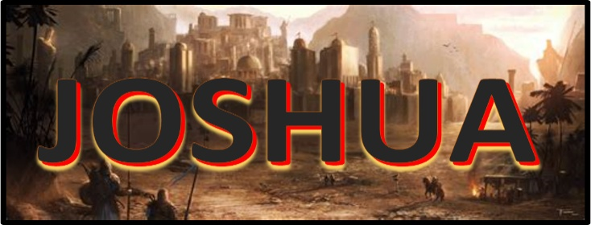
Topic: Joshua 11:1-23
Discussion on: 5/5/21
Commentary (Harriet)

- Who is Jabin? What is he doing? Why?
When Jabin, king of Hazor, was defiantly rejecting God. He was desperate to retain his own power in the land of Canaan. When he heard of Israel's victory over the 5 kings, he sent messages to the kings of the northern tribes asking for help to fight against Israel.
2. Who does Jabin recruit to go with him?
He recruits Jobab king of Madon, the king of Shimron, the king of Achshaph, the kings that were on the north of the mountains, and of the plains south of Chinneroth, and in the valley, and in the borders of Dor on the west, and the Canaanite on the east and on the west, and the Amorite, and the Hittite, and the Perizzite, and the Jebusite in the mountains, and to the Hivite under Hermon in the land of Mizpah. He recruits everybody that he can! They all agreed and combined forces at the water of Merom for the attack on the Israelites.
3. What did God say about the situation? What happened?
The Lord spoke to Joshua, telling him to “Be not afraid because of them: for to morrow about this time will I deliver them up all slain before Israel: thou shalt hough their horses, and burn their chariots with fire.” The chariots and horses were not to be captured, but destroyed so that the Israelites wouldn’t become dependent on them but continue to rely on God.
HOUGH:
To cut the tendons just above the rear hooves. This of course renders the horse completely unfit for war.
Joshua and his army prepared and made a surprise attack at the waters of Merom. The Lord fought for Israel as He said He would. The enemy kings were utterly defeated. Hazor was burned. The people inhabiting the other cities were destroyed, but the buildings themselves were retained for the use of the Israelites.
4. What does this chapter have to say about Joshua? Why?
This chapter includes a noble commentary on the character of Joshua. He obeyed implicitly every command of God. He had a simplicity of character that took God at His word and then acted on that word, whether the future was all understood or not. Some men are faithful only in things that they can fully understand and are in full agreement with. But true fidelity to God aims at full compliance with His will. Personal wishes and desires may conflict with known duty, but the surrendered soul chooses the will of God no matter how difficult the experience may be to natural inclinations. To a noble-minded man like Joshua, the work of blood and judgment must have caused great pain. But like a true soldier he respected the orders of his Commander. He left no known duty unfulfilled.
5. Consider verses 19-20. What does this say? Why is God hardening hearts?
God does not exercise arbitrary power to control a person against their will. The case in question has nothing to do with the free moral agency of man, which permits him to choose eternal life and does not prevent a contrary choice. God was here dealing with nations that had already refused His repeated offers of mercy. They had been given ample opportunity for repentance. Now divine justice demanded their prompt execution. And selected the means of their extermination. Note in verse 20 that it states “that they might have no favor…” This implies that they might have had favor had they behaved differently. God gives us all the opportunity to choose and it is we ourselves who choose to live in Him with soft hearts, or to harden our own hearts past all of His appeals. Hopefully we choose better than did these ancient Canaanites!

APPLICATIONS TO MY LIFE:
TBD

