
Topic: Joshua 12:1-24
Discussion on: 5/19/21
Commentary (Katie)

- This seems like a sudden shift of narrative style. What’s going on here? What is Chapter 12 about?
The narrative is about to shift into a description of the distribution of the land among the tribes. Before that, there is a brief summary of the work that has been accomplished. This chapter gives a short account of the victories of Israel and the defeats of the Canaanites. Thus it describes the extent of the conquest and shows the land open for settlement. The first part (verses 1-6) describes the territory to the east of the Jordan and the list of kings conquered by Moses, while the remainder of the chapter offers a catalogue of those on the west side of the Jordan that were taken by Joshua.
2. Examine the map. What areas are we speaking of here? Circle all of the place-names from this chapter that you can find.
(See attached map) Although I can’t locate every name, and not every location can be determined with certainty, there are enough consistencies to make it clear that the Israelites conquered vast areas of Canaan. Under Moses, they obtained a great deal of land east of the Jordan. And under Joshua, they were able to claim even more land in the populated and desirable regions west of the Jordan.
3. Compare verse 8 and Deuteronomy 7:1-2. What’s going on here?
The verses in Deuteronomy 7 make it clear that there are seven nations: the Hittites, Girgashites, Amorites, Canaanites, Parizzites, Hivites, and Jebusites living in the region the Israelites were to conquer. They were all “greater and mightier” than the Israelites, and they were to be utterly destroyedby the Israelites. Joshua 12:8 makes it clear that six of these nations (the Hittites, Amorites, Canaanites, Perizzites, Hivites, and Jebusites) were conquered by Joshua. The Girgashites aren’t mentioned. It’s been suggested that the Girgashites had by this point (some 38 years after God had first intended for the Israelites to begin their conquest in Canaan) been incorporated with some of these other nations. There is a Jewish tradition that the Girgashites had withdrawn to Africa upon the approach of Israel under Joshua, leaving their country to be possessed by Israel. The Girgashites inhabited an area to the north of the lake Gennesaret, or Galilee, and are supposed to have migrated in a body at the approach of the Israelites. In either case, the Girgashites were also, in effect, removed from the land.
4. Consider verse 14. What happened with the king of Arad? Review Numbers 21:1-3 and possibly Wilderness Wanderings Discussion 9.
The king unwisely attacked the Israelites. He seems to have approached them dishonorably, sneaking up from behind. He was able to take prisoners, presumably capturing a few stragglers from the main group. He was to regret this action! Moses sought God’s help, “And the Lord hearkened to the voice of Israel, and delivered up the Canaanites; and they utterly destroyed them and their cities.”
5. Just to complete our geographical orientation, what else happened at…
• Hormah? (Numbers 14:31-45)
After the first spies had returned from the land of Canaan and given their dishonest report, the people refused to enter the land. God commanded that they turn back into the desert, and the people obstinately decided that they would have the land after all. So they turned back and fought the Amalekites against Moses’ advice and God’s direction. The survivors were driven to Hormah by the Amalekites.
• Adullam? (1 Sam. 22:1)
Many years after the events described in this chapter, David would flee from Saul and find shelter in a cave located in Adullam.
• Kedesh? (Judges 4:6, 9-10)
This was the home (many years later) of a general named Barak. He fought Sisera at Deborah’s direction, and assembled his men at Kedesh for the fight. Barak won the battle, but Sisera fled only to be killed by a woman. Jael killed Sisera by hammering a tent spike through his head.

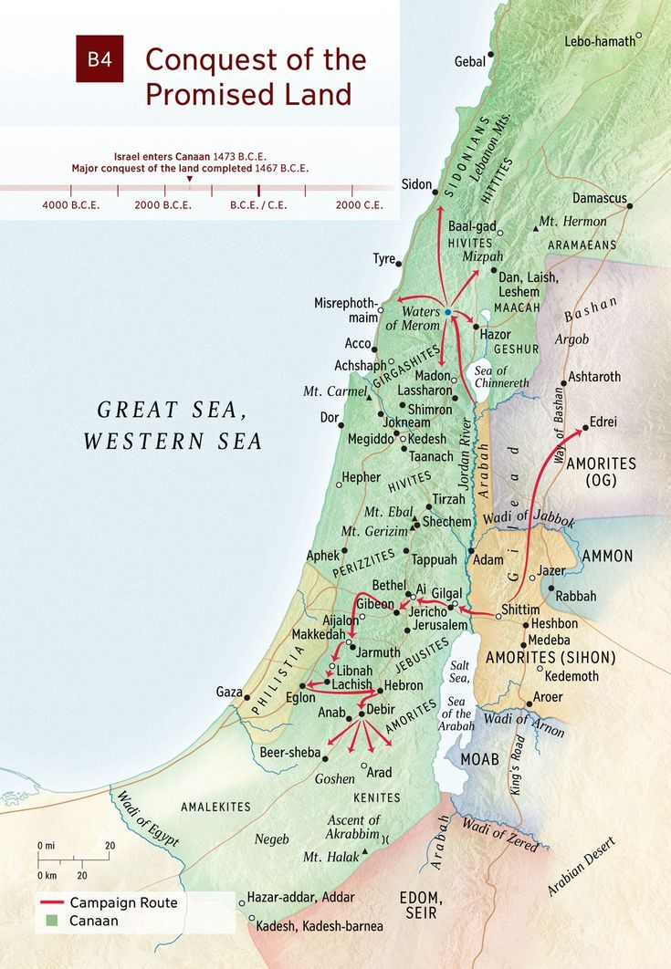
APPLICATIONS TO MY LIFE:
We often think we are weak and can’t accomplish much. But the Israelites—a group of untrained, unequipped, runaway slaves—were able to conquer this vast area, previously controlled by a whole collection of different tribes. God can empower us too, if only we would learn to trust in Him!

