
The Time of the Judges

Judges Chapter 2: Discussion on 8/18/21
Responses suggested by: Beth

- Who is speaking in the first five verses of this chapter?
The speaker in the first five verses is an “angel of the Lord,” that is, the Lord Himself. He is sometimes referred to by this title (see Exodus 23:20, 23; 33:2). Since the message is not introduced with a “thus saith the Lord,” which was the custom of later prophets, it suggests that the speaker was the Lord Himself. The use of the first person also suggests this view.
- What is the charge against the people in verse 2? Was this accusation accurate?
The charge against the people in verse 2 is… not obeying God. God has given the people two explicit instructions: 1. Do not make deals with the heathen inhabitants of Canaan, and 2. Destroy the heathen altars of Canaan. As we saw in the last chapter, the Israelites have been making arrangements with a great many Canaanite cities, which directly opposes God’s orders to “make no league with the inhabitants.” Naturally, as the Israelites had allowed many Canaanites to continue inhabiting their cities, the Israelites had also allowed them to keep their heathen places of worship. This also directly violates God’s directions. The people have gone precisely and repeatedly against God’s orders, which makes the charge of disobedience very accurate indeed.
- Consider verse 10 concerning the new generation after that of Joshua. What accusation is levied against them in this verse? What consequence might we draw from this statement?
This was a generation that had grown up in the land of Canaan subject to the corrupting influences of social and religious association with the idolatrous people of the land. This generation is accused of forgetting their history! They failed to study their forbearer’s experiences with God in the wilderness. Apparently their parents did not do their job effectively, as God had directed the parents to instruct the children in their people’s mighty history. The children were reaping in abundant measure what their parents had sown. These are profoundly meaningful lessons for us. Failure to examine the history of God’s people will lead us to the same disregard of His power. Parents are obligated to guide their children in studying this history. We call it “Bible study,” but it is also the close examination of history—specifically the way that God has led His people in the past. There is a great deal to be gained from such a study. And there is great risk in remaining ignorant, as the Israelites proved.
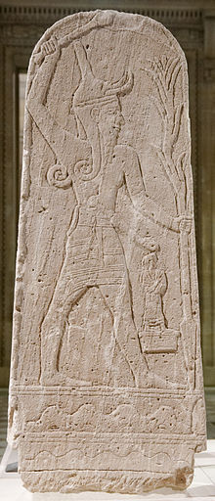
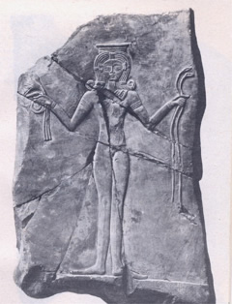
- What effects came from the Israelites’ failure to separate themselves from the influence of the Canaanites? See verses 11 to 13.
The Israelites forsook the Lord God of their fathers and did evil in the sight of the Lord. They served heathen gods like Baalim and other false deities that were served by the people around them. They bowed themselves down to idols and provoked the Lord to anger. They served Baal, a god of fertility, war, and weather. It’s a little difficult to get details, because the word “Baal” means “master” and is probably a general term for a number of local deities. Over time these cults merged and specific larger cults developed. The god or gods called Baal normally required the sacrifice of children, often first-born male children, generally sacrificed by fire. The hideous practices of this cult made it one that God (and His prophets) denounced often. The Israelites also came to serve Ashtaroth, a moon goddess of fertility, worshiped with sexual fertility rites. These were particularly distasteful to God as they involved sexual immorality to a disturbing degree. Due to their disobedience, the Israelites were drawn into such evil practices.
- How did God react to such flagrant disobedience in verses 14 and 15?
“And the anger of the Lord was hot against Israel...” and He turned them over to various nations within Canaan that raided, invaded, oppressed, or otherwise molested Israel. The Lord was not with them, so they won no victories in battle.
- We’re told that “Nevertheless the Lord raised up judges, which delivered them…” in verse 16. Why did He do such a thing for such a defiant and disobedient people? See also verse 18.
After a period of punishment God would give the Israelites respite by enduing a chosen man or woman with power and leadership sufficient to drive off the oppressors. It was a test to reveal if they had learned from the consequences of their religious apostasy. God did this for them because He was grieved because they had to suffer oppression. When the punishment brought forth desired effects, God’s pity raised up deliverance for the oppressed. God’s purpose was to change their conduct. When this was achieved, the oppression was removed. This was entirely consistent with His original purpose.
- How did the people respond to the judges?
The people repented and worshipped the Lord while the judge was alive and leading them. When the judges dies, the people returned to their former apostasies. They left off the worship of God and turned to the worship of heathen deities.
- Surely God was aware of the consequences of leaving the heathen nations to continue corrupting the Israelites. What was His purpose in doing so? Why?
God allowed trouble to come as a result of sin to arouse His people and see the evil of their ways. The people chose to remain in contact with the heathen nations around them, and God allows people to have choices. He was endeavoring to teach them what would happen when they were exposed to close and constant contact with heathenism. As He certainly was aware they would, the Israelites readily abandoned their history and faith. They were immediately drawn into what must have seemed the glamorous rites of heathen gods. The bitter consequences which followed were to teach them the pain of apostasy.
What have we learned with this chapter? How can we apply it to our lives?
“Blessed is the man that endureth temptation: for when he is tried, he shall receive the crown of life, which the Lord hath promised to them that love him.”
-James 1:12
“Let us hear the conclusion of the whole matter: Fear God, and keep his commandments: for this is the whole duty of man.”
-Ecclesiastes 12:13

This should be an important lesson about priorities. The Israelites became focused on settling the land of Canaan. They saw practical advantages in making deals with the Canaanite cities to supply workers to help them settle the land. They prioritized success in their new land and failed to prioritize the One who had given it to them. We often succumb to the same problem of prioritization today. We have many important tasks, and it can be difficult to remember in our daily lives that God comes first. The Israelites lost the land that they had been given because they put it first. We don’t want to do the same.

