
The Time of the Judges

Judges 18:1-31: Discussion on 2/9/22
Responses suggested by: Katie

- What problem are the Danites endeavoring to solve here? Why?
The Danites had not been successful at settling the territory which they had inherited by fair division during the time of Joshua. The allotted territory of Dan was on the lowland between the sea and the hills, but the Danites were unable to take it from the Canaanites who lived there. They had been forced by these Canaanites to move back into the mountainous country. It seems that many of the Danites had decided to abandon all attempts to settle in their inherited land and instead take land wherever they could find it. So they sent out some of their tribe to look for a place that they could conquer more readily. Of course, this was contrary to the original plan of God, who had given them their inheritance within the inheritance of Judah. Trust in God would have enabled them to drive out the inhabitants of the land. Instead, they migrated northward, openly admitting their unwillingness to follow the plan of God.
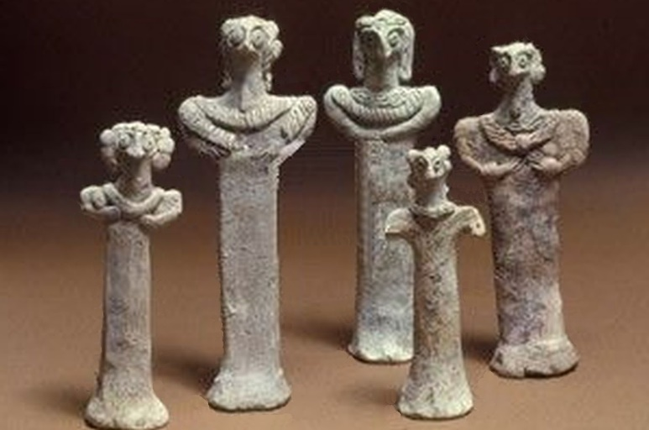
- What do the Danites ask the Levite to do in verse 5? Why? How does he answer them?
It seems that when the Danites discovered that the Levite “priest” had the implements to cast an oracle (an ephod and teraphim), they requested that he inquire whether or not their exploratory tour would turn out successfully. It seems that both the Danites and the Levite “priest” believed that God could be consulted in such a manner. The Levite told them that their trip would be under God’s observation and favor. The word for “Lord” used here is Yahweh. This Levite was practicing the worship of the true God under forms of worship forbidden in the Mosaic law.
- What do the Danites decide to do?
The Danites came to Laish, and saw that the land was good and the people peaceful, without either rulers or allies. So they went back to the larger group of their people and reported on their findings. The Danites decided that they should go and take the area for their own. They sent a force of some six hundred warriors, plus women and children, to occupy the area around Laish. (The Danites changed its name to Dan after they captured it.)
- What do the six hundred men of Dan decide to do on their way to conquer Laish? Why?
The five men that had previously come to spy out the area made a point of telling the others that there was a collection of religious objects nearby. They also suggest that the force should consider what to do in order to get the ephod, teraphim, and graven image into the possession of the Danites. It appears that they wanted this collection of objects to use them in their own devotions (assuming that’s the correct word). It seems that one group engaged the Levite in conversation while the others slipped into the shrine to appropriate the religious objects.
- What offer do the Danites make to the Levite? Why?
They suggested that he come with them and “be to us a father and a priest,” since it would be better to be priest to a whole tribe than just for one man. In exchange for his silence—and his consent to the theft of the religious artifacts from Micah’s house—the Danites seem willing to make the same kind of arrangement with the Levite that he previously had with Micah. It seems that the Danites desired to have contact with God, much as Micah did. And like him they do not seem to have a proper understanding of (or belief in) the laws surrounding worship of the true God. They seem to want the religious objects so that they can use them, and the priest so that he can serve them in a religious fashion. We know that Israel was in apostasy at the time, and the Danites seem to have been in apostasy to an exceptional degree. They’re taking over lands which are not their own, stealing idols belonging to other people, and now suborning an apostate priest for their dubious religious services.
- How does the Levite respond? Why?
The Levite “was glad” to steal religious artifacts not belonging to him and abandon the man who had treated him kindly. He had first betrayed the pure worship specified by the law of Moses to minister before Micah’s idol for the sake of money offered to him. Now he abandons his benefactor (who had treated him as a son) and gladly accompanied the thieves who had stolen his goods. Of course, Micah himself was a thief. The Levite was faithless and mostly invested in profit, and the Danites were lawless freebooters. None of the characters in this narrative are exemplary, but the perfidy of the Levite is noticeable even among this cast of characters.
- What do Micah and his townspeople do in response? Why? How do the Danites answer them?
Micah and the villagers go after the Danites when they realize that their idols (and priest) had been stolen. The theft of the images was regarded as a loss to the entire villiage, and not to Micah alone, since the townspeople probably worshipped at Micah’s shrine. Micah accuses the Danites of their theft. In response, the Danites threaten him, suggesting that the hot tempered among them would simply kill Micah and his townspeople. Perceiving that the Danites were stronger than his own forces, Micah has to turn back.
- What happens to the idol(s)? Why?
The Danites take the idol or idols with them to Laish. After they take the city and change its name to Dan, they set up the idol or idols and had their stolen priest hold worship in front of the images. Presumably, the arrangement was very similar to what it had been with Micah, only the whole city of Dan worshiped at the shrine with the idols and false priest.
What have we learned with this chapter? How can we apply it to our lives?
One kind of wickedness leads to another! The Danites were not doing what they were supposed to be doing. They did not take the land that they were supposed to take, seeking an easier way. That easier way leads them directly to theft, threats of murder, and blasphemous forms of worship. Let’s not fool ourselves into thinking that some small, wrong thing is really unimportant—every sin leads to more!

