Supplemental Material on Judges 19
Consider these parallels to the Sodom and Gomorrah story:
Judges 19 | Genesis 18 & 19
2-9 Levite and unfaithful (whoring) concubine hosted for five days by her father | Abraham & Sarah (unable to produce children) host three divine visitors
10-21 Couple travel to a courtyard of a city in Benjamin where no one takes them in except an old man who is also a foreigner to the city | Angels travel to courtyard in Sodom and Lot (a foreigner) hosts them.
22 Men of city beat at door, want sexual relations with the visiting man | Inhabitants of city come to door, want sexual relations with the visitors
23 The old man pleads to people, “do not so wickedly”[i] to his guests | Lot pleads to people, “do not so wickedly” to his guests
24 Old man offers his “maiden” daughter and his concubine[ii] – “do with them what seemeth good unto you” | Lot offers his two virgin daughters – “do ye to them as is good in your eyes.”
25 Men reject old man’s offer so the guest offers his concubine and “they knew her, and abused her all the night until the morning” | Men reject Lot’s offer, want to “do worse” to Lot, but Lot is protected.
26-28 Concubine crawls to doorstop and dies. | Lot and his household are protected behind the door.
29 -30 Husband cuts her into twelve pieces and sends throughout Israel, which realizes “there was no such deed done nor seen from the day that the children of Israel came up out of the land of Egypt.”Chapter 20: War declared on Benjamites and they are nearly destroyed | Sodom destroyed for its wickedness
Chapter 21: Virgins provided to Benjamites to repopulate tribe. | Lot’s virgin daughters have sex with him in order to have posterity.

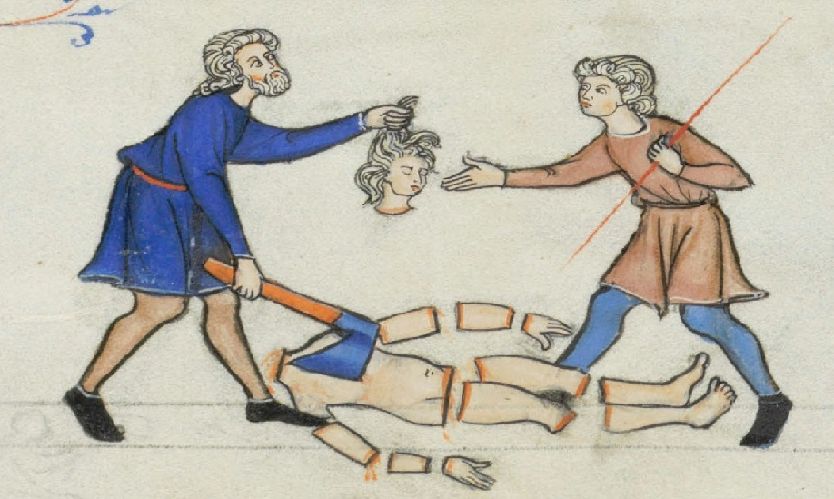
Doug Batchelor on Judges 19
Michael: Yes sir! Thank you for taking my call.
Doug Batchelor: And how can we help?
Michael: My question is on Judges Chapter 19. It seems pretty brutal to me and I don’t quite understand why they did what they did to the concubine?
Doug Batchelor: Just for our friends who are listening, this is a very disturbing story. The Bible doesn’t pull any punches; it gives the history – good and bad, and that’s why we believe it’s a true book because it tells some things that happened. It doesn’t paint anyone in the glorious light but it was accurate.
This really happened. There was a man of Ephraim whose wife wasn’t faithful. She ran home to her father in Bethlehem. He went to retrieve her because he loved her and he was willing to forgive her. He was delayed along the way.
On the way home they couldn’t make it home before sun down. They decided to just stay with somebody. Someone took them in from the tribe of Benjamin. I think it was the town of Gibeah.
The people of the town broke in and she was abused so badly that she died. This man then when he got home, he took his wife’s body and he sent the 12 parts of her body to the 12 tribes and said, “Look, you need to come and we need to visit judgment on the people of this town for doing such a thing.”
This is before they had a king. So they had to kind of rally. Now, are you wondering why is this there or why did they treat her that way?
Michael: Well, actually you’ve already kind of helped me out in the fact that I didn’t realize from reading the story that when he found her on his threshold that she was already passed on.
Doug Batchelor: Yeah, he made to the…
Michael: (unintelligible) chop her up?
Doug Batchelor: Oh, no.
Michael: And I was thinking they were just doing it out of spite because they used her to save their own butt and then sent her out to be used and abused and then when she came back, used and abused her.
Doug Batchelor: When he went, they opened the door and she had died at the threshold. There’s a very strong spiritual analogy or symbolism in this story. The Bible tells us that the wife, the bride or the church rather is like the bride of Christ. She has been unfaithful. He came to this world to a town called Bethlehem to forgive and reclaim her, and she was willing to go home with him. But on the way home, she was attacked by the world.
You can read in Revelation why the bride of Christ is viciously attacked and she has to flee for her life. There’s a lot of analogies here, and then there’s a great judgment day in the story in Judges and there’s a great judgment day because of what the world has done to God’s people.
So there’s some very powerful analogies in the story of Judges. It’s a true story but there’s also a spiritual lesson there.
Jëan Ross: You also read the next chapter that tells you the result of what happened. The Israelites were just really indignant. One of the tribes, Benjamin, who would do such a thing and half of those who did this, and as a result, there was actually a civil war, you can read on, that broke out between the rest of the tribes and the tribe of Benjamin and several thousands of people were killed in that battle, in that war, as a result of this.
It was a very serious thing and I think that’s probably why we also have it listed in scripture to reveal how deprived a human being can actually become and are hardened if they take their heart off Christ.
Doug Batchelor: Absolutely, and Benjamin was decimated. It used to be one of the biggest tribes and then after this experience, it became one of the smallest. But hope that helps a little bit Michael. It is a different story.
Michael: It does very much.
Doug Batchelor: Glad you called in. Thank you for your call.
Michael: Well, thank you.
Doug Batchelor: God Bless.

