


Ruth
Ruth 2:1-7: Responses for Discussion
April 13th

- What activity does Ruth propose in verse 2? Why? What does this tell us about Ruth?
Ruth suggests that she should go out to the fields to glean “corn,” that is, grain. The activity of “gleaning” involves gathering food, in this case grain, that has been missed by the harvesters. Presumably she was actually gleaning barley, since we know that Naomi and Ruth arrived “in the beginning of barley harvest” (1:22) and Ruth gleaned “unto the end of barley harvest” (2:23). Due to this timeline, it’s clear that Ruth went to work directly after their arrival in Bethlehem. Presumably someone needed to support them. Naomi herself did not go out to glean grain. She might have been recovering from the difficult journey, or possibly she was just suffering the infirmities of age. Ruth plainly stated her kinship to Naomi when she determined to go with her to Bethlehem. Now she demonstrates the sincerity of her motives by taking the initiative and laboring diligently to provide for the needs of Naomi.
- Compare Leviticus 19:9-10 and 23:22. What command is given here? Who is supposed to benefit from the gleanings? Does Ruth qualify?
The landowner is commanded to “not wholly reap the corners” of their field, nor collect the gleanings of the field themselves. They aren’t supposed to squeeze every bit of possible profit out of their harvest. The gleanings are dedicated for the support of the poor and the stranger. Ruth was doubly qualified, both as the “poor” and as the “stranger”! This provision was made for supplying the needy with the necessities of life, and for teaching those more favorably situated lessons of unselfishness and compassion. Notice particularly that the needy had to work for what they received, and did not become merely the passive recipients of charity. This preserved their self-respect and encouraged initiative and industry. It’s a lesson that the charitable of today need to apply carefully!
- What is the geography here? Where is the “field”? Draw a picture! What does it mean that Ruth came to a part of the field belonging to Boaz?
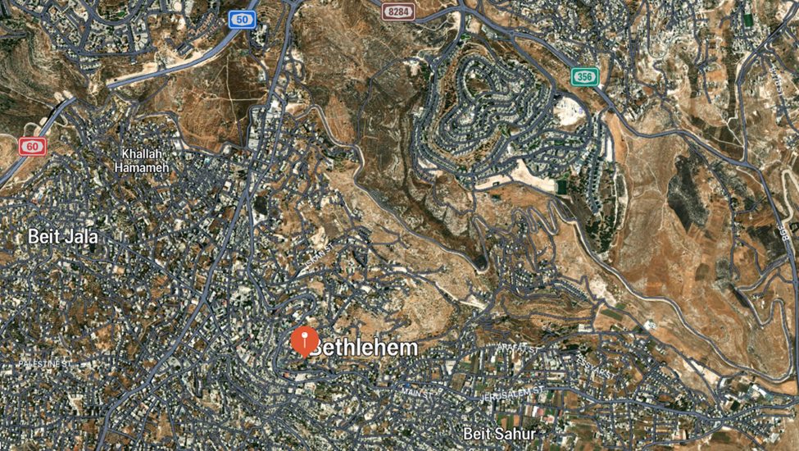
The “field” would be the entire cultivated area around Bethlehem. The townspeople would cultivate the ground in an appropriate area, and that ground would be divided into areas of responsibility. Thus, Boaz’s field is just a region of the cultivated area. So it makes sense that Ruth would wander into a part of the field belonging to Boaz.

- What is Boaz’s question in verse 5? What are the implications of this question?
Boaz asked, “whose damsel is this?” Boaz seems to have recognized the other gleaners, of whom he speaks as “my maidens.” It seems that the owner of the field had to give permission for a person to glean in that field. Possibly those who gleaned in a certain field customarily did so by invitation. The owner could then reserve gleaning rights for those he considered most deserving. The fact that Boaz did not recognize Ruth indicates that he had not yet met her.
- How does the servant answer him? What are the implications of his response?
The servant seems to know all about Ruth, her origins and her arrival with Naomi. It seems this was common knowledge in the town. The fact that Boaz had not yet encountered Ruth even though he was fairly closely related to Naomi suggests that Ruth must have begun gleaning almost immediately after arriving in Bethlehem.
- In light of your response to question 3, what does it mean that the servant says Ruth “tarried a little in the house?”
In Oriental lands farmers live in villages or towns, and the fields they till are out in the surrounding countryside, often at some considerable distance. In going out to glean, Ruth had left “the city” and at night she returned to it, but not during the day. The Hebrew here is not entirely clear. The LXX (along with the Syriac and the Vulgate) translates this as “without resting even for a moment.” Everything about this story emphasizes that Ruth was faithfully dedicated to Naomi, and that she was a hard worker.
- Are there any other pieces of information you’ve discovered in the course of your research that you would like to mention?
The settlement currently located on the ancient site of Bethlehem-Judah is called Beit Lahm, which is an Arabic phrase which can be rendered as “house of meat.” This is curious, because before the settlement was called Bethlehem, it was called Ephratha. As you might remember, “Ephratha” can be translated as “house of bread.” Of course, both “meat” and “bread” are traditionally alternate words for “food.” The town must have been a major food producer! So I guess it makes sense that so much of this story revolves around food, and the grain harvest in particular!

