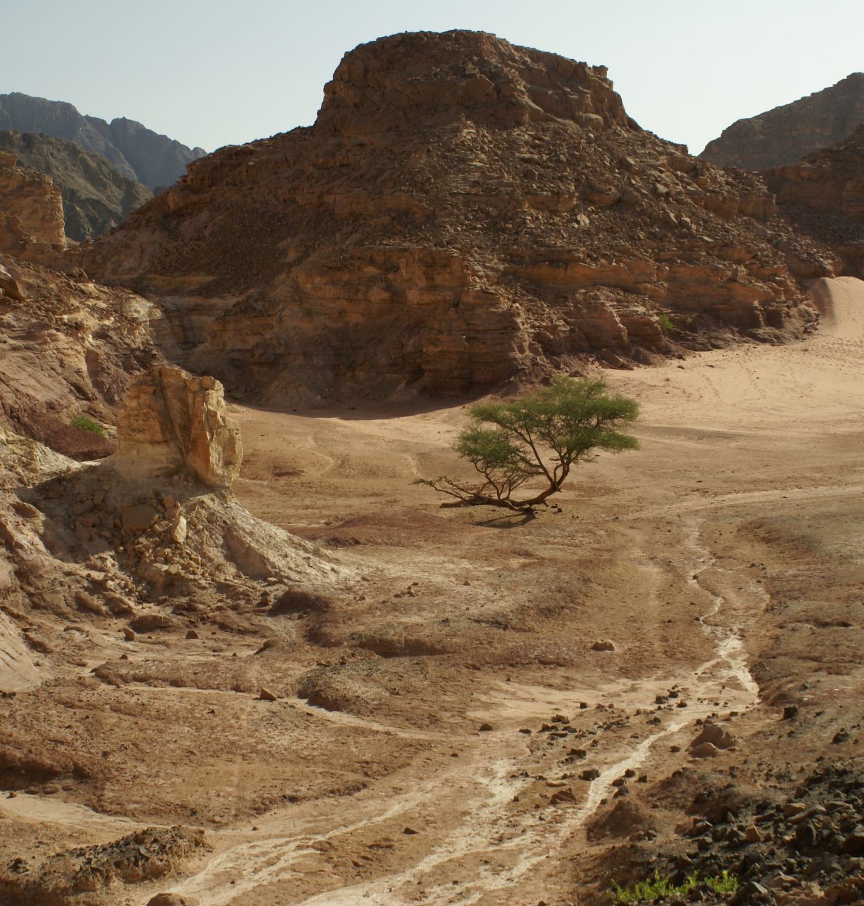
The Israelites’
Wilderness Wanderings
Excerpts from Leviticus, Numbers, and Deuteronomy

