The Israelites in the Wilderness Discussion # 03—Prepare for 7/22/20
Read: Numbers 12
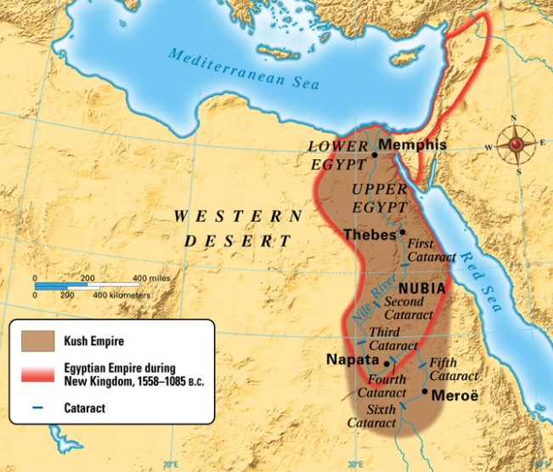
Why were Miriam and Aaron unhappy? Consult Numbers 11 as well as Exodus 18.
Miriam and Aaron, we’re told, spoke against Moses “because of the Ethiopian woman whom he had married.” Ethiopian, in this case, is a translation of “Kushite.” Kush was the empire that occupied the Nile River Valley before Egypt. They were pushed up river (to the south) into what is now the Sudan as the Egyptian empire took over. Many of the Kushites were dark-skinned. So many people believe that this statement suggests that Miriam and Aaron were racist, or at least, prejudiced against black people. And while that’s always possible, given that they were flawed and human, there’s a lot more going on here. You may remember that Jethro, Moses’ father in law, had brought Zipporah and the children to Moses at Sinai (Exodus 18:6). Jethro had seen the burdens on Moses and counseled him to select others to share his responsibilities. In Numbers 11, Moses acts on this advice without first consulting Miriam or Aaron. They became jealous and blamed Zipporah for what they considered to be Moses’ neglect of them (Patriarchs and Prophets pg. 383). They used the fact that Zipporah was a Midianite to suggest that Moses had violated the principle of non-marriage with the heathen. Of course, Zipporah was a follower of the true God and descendent of Abraham, as was Jethro, but Miriam in particular used this excuse to generate discontent, because she was jealous of Moses’ authority and that of the 70 elders. And Aaron came to share her opinion.
We aren’t given an exact description of Moses’ reaction to his siblings’ complaint, but we are given some insight in verse 3. How do you think Moses reacted? Consider Numbers 11:29.
According to Patriarchs and Prophets, “their accusations were borne by Moses in uncomplaining silence.” Moses was “very meek,” a character trait learned in forty years in the wilderness in Midian. Only a meek man knows how to be submissive to God and to his subordinates and at the same time be a courageous and dynamic leader. There is no place in the work of the Lord for a leader who conceives it to be his privilege to domineer over his fellow workers and dictate to them. Thus Moses accepted the complaints of his siblings, understanding their jealousy, until God Himself took action.
How does God react to this situation?
God had chosen Moses and but His Spirit upon him. Miriam and Aaron, by their complaints, were guilty of disloyalty, not only to Moses, but to God Himself. He came down “in a pillar of cloud” and called Miriam and Aaron to the tabernacle. There He informed them firmly that He chose those who spoke for Him. And He points out that Moses was granted the privilege of speaking to God more directly than anyone else. Then God punishes Miriam for her disobedience and disloyalty.
Consider verses 7 and 8. What is God saying here about Moses?
Moses was granted closer communion with God than anyone else. God spoke with him directly, with no intermediary. Moses saw God, not the actual being of God which he would not survive, but some visible form of God that a man could see and appreciate. Moses had an extremely close relationship with God, which gave him authority that no one else could hope to have unless they also developed such a relationship.
Consider God’s question in verse 8. What are we to learn from this? Compare 1 Samuel 26:11, Matthew 23:3, Daniel 2:21-22, Proverbs 21:1.
The fundamental mistake of Miriam was one of disrespect for, and rebellion against, authority appointed by God Himself. We know that God appoints our leaders too. We are obligated to obey those that God places over us, at least in so far as our obedience to God allows. There are many other examples of this requirement in the Bible.
What punishment did Miriam receive in verses 10-12? Why did the punishment fall upon Miriam rather than on both Miriam and Aaron?
Miriam became leprous, “white as snow.” Evidently the whole outcry was worked up by Miriam. The whole thing was a rather feminine plan, relying on social manipulation and natural resentment of an outsider. So Miriam must have been the driving force behind the problem. Leprosy, a dreadful disease involving both physical disfigurement and being cast out from society and regarded as spiritually unclean, is a peculiarly appropriate punishment for the type of social manipulation which Miriam had attempted. Aaron received no physical punishment, but he was undoubtedly disturbed by Miriam’s leprosy. Patriarchs and Prophets, pg. 385, says that Aaron was “severely rebuked in Miriam’s punishment.” And that for both Miriam and Aaron, their pride was “humbled in the dust.” Aaron certainly immediately begged that Miriam might not be left to perish from the leprosy.
Consider verses 13-15. Ultimately, what was Miriam’s punishment? Why? Compare Leviticus 13:4.
The words of verse 14, that Miriam might return a week from the time that leprosy struck her, imply that she was healed immediately, and began the ritual of purification immediately. God points out that even if Miriam had been shamed by her father, rather than being shamed by God Himself directly, she would have been “ashamed seven days.” It was therefore just that at least she be shut out of the camp for seven days, given that she had been punished by God.
Notes and Observations:
- It was true, as Miriam and Aaron say in verse 2, that God had revealed His will to them as well as to Moses. But they use this fact to suggest equality to Moses, ignoring the reality that God had placed Moses in a unique position of authority.
- God has always revealed His will to His servants the prophets through visions and dreams, and in verse 6 He promises to continue to do so. But God’s method of communion with a few men, including Moses, has been unique to His relationship with them. God spoke with Moses directly, rather than through visions and dreams.
- The Israelites stayed where they were encamped until Miriam was able to return to the camp. Patriarchs and Prophets, pg. 385, says “In respect for her high position, and in grief at the blow that had fallen upon her, the whole company abode in Hazeroth, awaiting her return.” This was a very public punishment, intended to “check the growing spirit of discontent and insubordination.”

