The Israelites in the Wilderness Discussion # 09—Prepare for 9/23/20
Read: Numbers 21
Describe the conflict in verses 1-3. Who is fighting whom? Why?
The name “Arad” probably refers to the place rather than the person, as in, the king of Arad. Arad is about 50 miles north of Kadesh and 17 miles south of Hebron, and is known today as “Tell ‘Arâd.” The king of Arad apparently cut off a few stragglers in the rear or on the borders of the line of march. If he had attacked the main body in force, there would have been some account of battle casualties. Instead, he simply captured a few people on the margins. The Israelites then appealed to God for help in punishing the king of Arad. God consented, and “delivered up the Canaanites.”
Why did the people complain in verse 5?
There were a number of discouraging factors. The part of the country through which they were travelling, the Arabah, is a barren plain strewn with stones and sand. They had been denied passage through Edom and were on their way to Ezion-geber. In other words, they were marching with their backs turned to Canaan instead of entering it. The actual content of the people’s complaint was that there was no bread or water and that they hated the manna. The people were thinking of the varied and spicy foods of Egypt, and they were rebellious of the monotony of their diet.
Does God really send fiery serpents to bite the people? Why?
In a manner of speaking! The deaths were due to the withdrawal of the protecting hand of God. The part of the country through which they were traveling was infested with snakes, scorpions, and so forth. Every day provided miracles of divine protection. But now the Lord withdrew His protection and permitted the snakes to attack the people. The serpents were called “fiery” on account of the violent inflammation caused by their bite. The people had been accusing God of all manner of deception and lack of care. They needed the reminder that God cared for their daily needs in ways that they didn’t even think about.
What does God instruct Moses to do to ameliorate the problem with the serpents? Why?
Moses was directed to make a serpent of brass like the snakes that had attacked the people and placed it on a pole where everyone would be able to see it. And everyone who was bitten, when they looked on it, would live. Snakes are emblems of the enemy, Satan, so a bronze serpent seems like a peculiar symbol for healing. But we’re forgetting a part of the image! This snake was defeated and draped upon a pole. How do you suppose that the Israelites, a nation of shepherds, dealt with snakes in their daily lives? This would be one reason why a shepherd carries a staff! They would kill the snake with their stick—much like we might use a hoe today. But a wounded snake may thrash around for hours. So it makes sense to use the stick to move the snake away from the flock. Thus the image of a dead or dying snake draped over a staff was one that should have been intimately familiar to the Israelites. This isn’t a beautiful brazen serpent climbing up a rod, but a dead or dying snake draped across the victorious shepherd’s staff. Which does make sense as an image of hope and healing—and Christ’s ultimate victory. The people knew that the serpent was a sign of the coming Savior. They also realized that it was not sufficient simply to look upon the serpent, but that the looking must be accompanied by faith, since there was no healing in the serpent itself. It was possible to gaze at the image without being healed, if there was no exercise of faith in God as the divine Healer. Similarly, offerings unaccompanied by faith were unavailing.
What is the situation with the kingdom of Sihon in verses 21-31? Compare Deuteronomy 2:18-37.
The Israelites sent a message of peace to the kingdom of Sihon, similar to the one previously sent to Edom. But God’s orders concerning Sihon were quite different. When they came out and attacked the Israelites, they invited disaster upon themselves by trying to destroy God’s people. The Israelites had been assured that they would be victorious. It must have been a heartening victory for Israel, new to warfare! Verses 27-30 are a poem or song about their victory. The territory Israel now occupied on the east side of the Jordan was that of the Amorites.
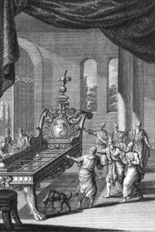
What was the situation with Og in verses 32-35? Compare Deuteronomy 3:1-22. What do we know about King Og?
Og occupied a serious stronghold, and apparently he was himself a fearsome warrior. He evidently was a very big man, a descendant of giants. Curiously, his bed was famous, being enormous and made out of iron to support his massive stature. Taking on such a fortification and such a warrior was quite an act of faith. Of course, had Og remained behind his fortified towers, Israel could scarcely have touched him. But due to his pride, no doubt, he chose to leave his fortifications and give battle in open country. And thus he was defeated by an underequipped band of runaway slaves, as God intended. God had delivered Og’s lands into the hands of the Israelites despite all his fortifications and giant strength.
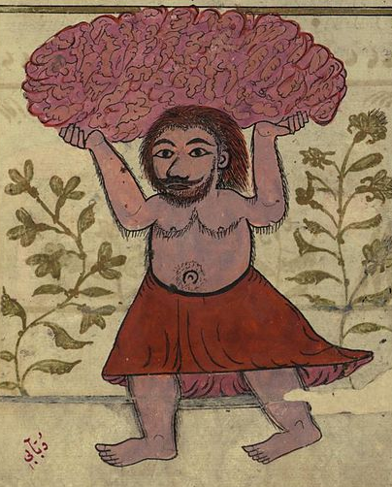
Notes and Observations:
- Og’s bed was apparently 13 ½ by 6 feet according to the “cubit of a man.” [The Jewish Talmud greatly embellishes the story, stating that Og was so large that he sought the destruction of the Israelites by uprooting a mountain so large, that it would have crushed the entire Israelite encampment. The Lord caused a swarm of ants to dig away the center of the mountain, which was resting on Og's head. The mountain then fell onto Og's shoulders. As Og attempted to lift the mountain off himself, the Lord caused Og's teeth to lengthen outward, becoming embedded into the mountain that was now surrounding his head. Moses, fulfilling the LORD's injunction not to fear him, seized a stick of ten cubits length, and jumped a similar vertical distance, succeeding in striking Og in the ankle. Og fell down and died upon hitting the ground.]

